Since its inception, Apollo Mechanical Contractors has grown exponentially. With this growth and expansion into emerging markets and different geographical areas, unique differences are an important part of what makes each of Apollo’s Divisions and Departments effective in their area of expertise.

With growth, comes the challenge of maintaining Apollo Mechanical Contractor’s original vision, while highlighting the unique characteristics of individual teams. To further strengthen our presence in the market nationally, and to preserve the Apollo Mechanical Contractors brand and logo, the following guidelines have been established:

These guidelines pertain to the logo, and information contained in the Logo Space as defined below. The intent is to protect the elements depicted in the logo, while allowing additional options for business development or other information that is used in conjunction with the logo.

For general business purposes:

Apollo Mechanical Contractors logo, including the words Mechanical Contractors, and the Building People tag line.
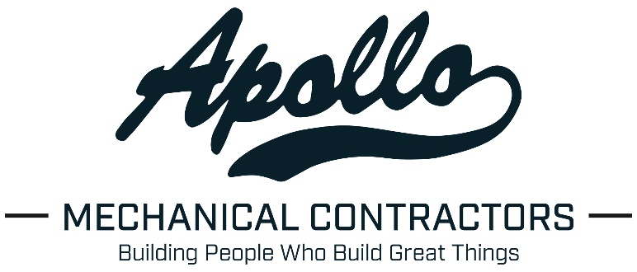

The elements of the logo that have been identified as protected are the swoosh below the word Apollo, the space occupied by the words MECHANICAL CONTRACTORS, and alternate slogans should not be used in lieu of the Building People tag line.

The Apollo Mechanical Logo may be used alone without the Building People tag line.

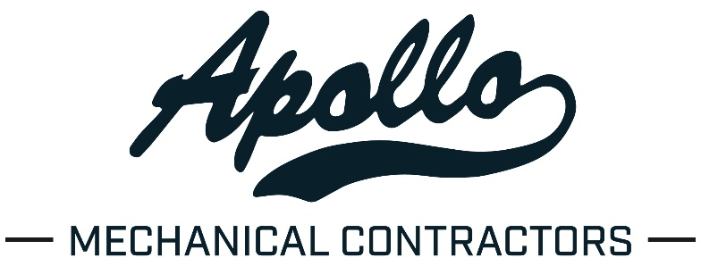

For use in marketing materials, proposals, prequalifications and any other media intended to represent the Apollo brand, a standard color palate has been identified. Deviations from this palate are allowed in cases where a particular theme dictates color choice (a client or owner theme colors, event theme, etc.)
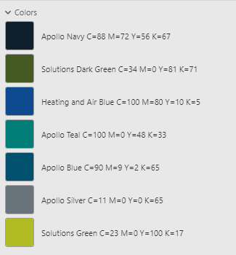

For Division Swag:

The simple Apollo logo (no Mechanical Contractors) logo may be used, provided no additional information is added to any area of the logo space:

Any additional images, slogans, project names or other information should be located separately from the logo and in another location (ie: sleeve or back of a shirt, back of hat, etc.)

In the case that a Division, Department or Group wishes to uniquely identify themselves, the information should appear below Mechanical Contractors. Mechanical Contractors should always be used so that the group or division is identified as a part of the larger organization. To maintain continuity (fonts, sizing, etc.) these variations should be created by the Corporate Marketing Department.

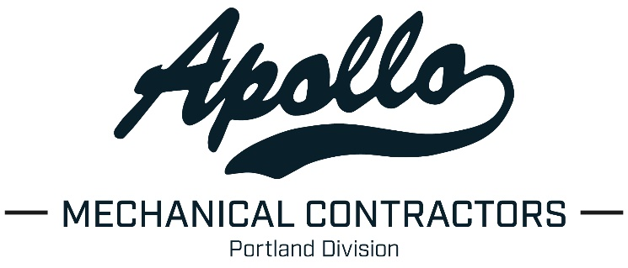
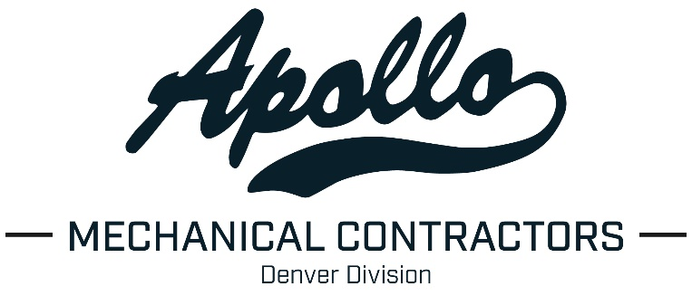

Two entities within the Apollo organization have been identified as unique, in that they both have their own Contractor’s Registration numbers that identify them with the state of Washington, and their scope of work, and their branding identifies them as specialized and unique. These logos are the only cases where words other than Mechanical Contractors will appear in the space directly below Apollo.

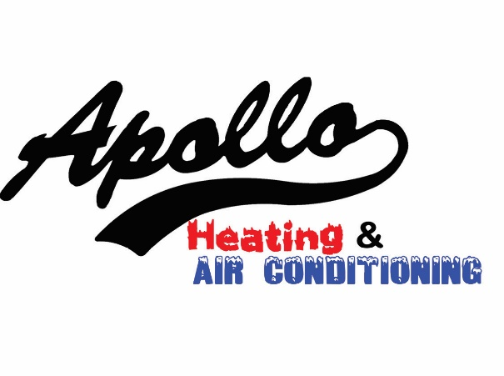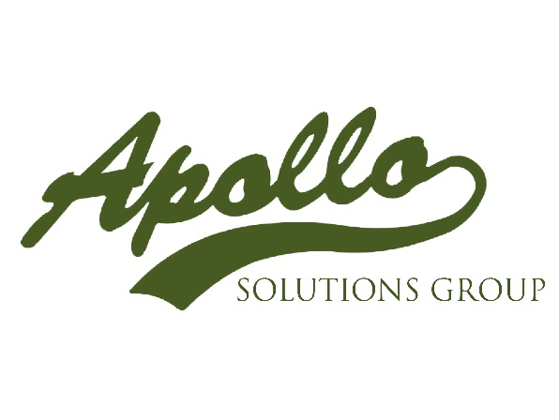

Apollo has identified and negotiated with a sole source provider for all items bearing Apollo logos or other branding information. AIA Platinum Promotions has been identified as this provider, and they have been provided a copy of Apollo’s branding guidelines.

Employees may contact them direct to order division swag:

Kit Jones
AIA Platinum Promotions
503-799-2958
www.aiaplatinum.com
kit@aiaplatinum.com

If availability of a specific items requires procurement from an outside source, please coordinate with corporate marketing.

Employees may purchase items for their personal use through the Apollo Company Store at: https://apollomc.aiacompanystore.com/
A link to this site can also be found on apollo’s website at www.apollomech.com

Items purchased at the Apollo Company Store are for personal use and are not to be purchased for groups using an Apollo company credit card. Any items that are being purchased by Apollo should be purchased using a PO/reference number, through AIA platinum as noted above.

