To further our efforts toward strengthening our brand and message, and to ensure that all correspondence sent on behalf of Apollo Mechanical Contractors portrays a unified and professional image, please use the following guidelines when generating official correspondence:

Letterhead
Official letterhead has been established for each divisional location. Letterhead can be found on the Apollo website, through the employee portal.

At the bottom of the home page, select Portal login.

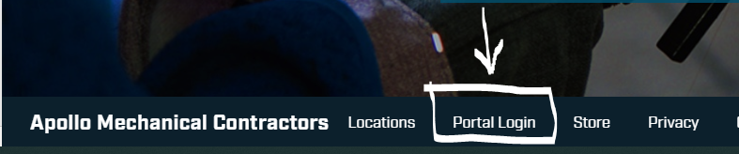

The Document Management System is password protected. Enter the password that has been provided. For login help, contact Apollo IT.
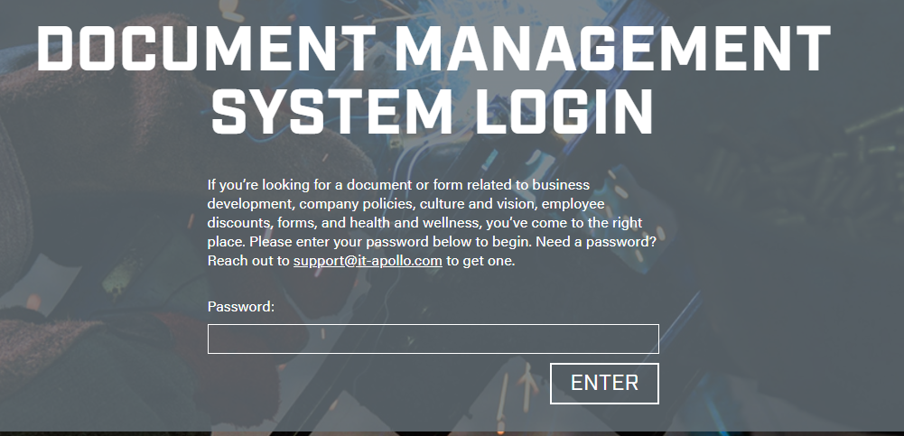

You can select “Letterhead” from the category drop down, or type “letterhead” in the search window.
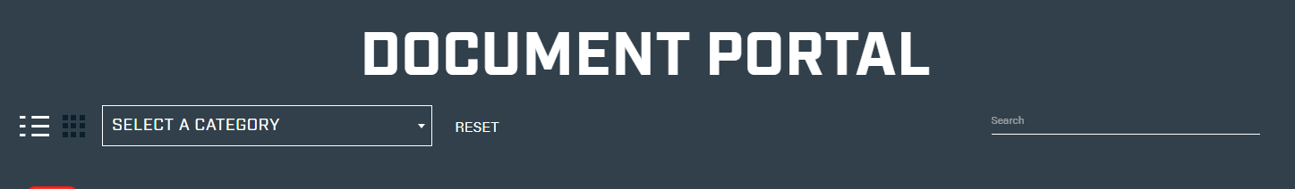

Click on the letterhead version you would like to use

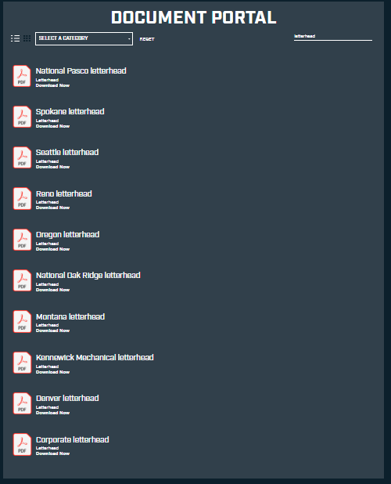

The selected letterhead will download to your computer, and can be found at the bottom of your window, or in “downloads”
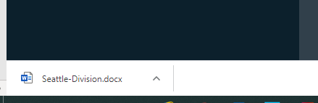
Click “Enable Editing” in the yellow bar at the top of the screen to begin using the letterhead.

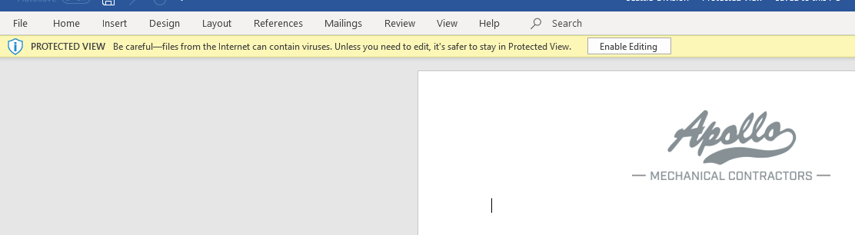

Letterhead should not be modified in any way. All letterhead revisions will be made by Corporate Marketing. Please contact them should revisions be required.

Business Cards
A sole source supplier has been identified for all business card orders. For convenience, an administrative contact has been established for each divisional location. This contact has direct access to the business card order portal and will be able to order cards as needed for their division. Contact Corporate Marketing if you are unsure who your divisional contact is.

Presentations
All presentations, both internal and external should carry the Apollo brand. Master Power Point slides have been created for this purpose. Master slides can be obtained and downloaded from the Employee Portal (see steps above under “Letterhead” and search or select Slides and Presentations from the Category Drop Down or Search window.

Click “Enable Editing” in the yellow bar at the top of the screen. Slide masters direct where information should be edited.
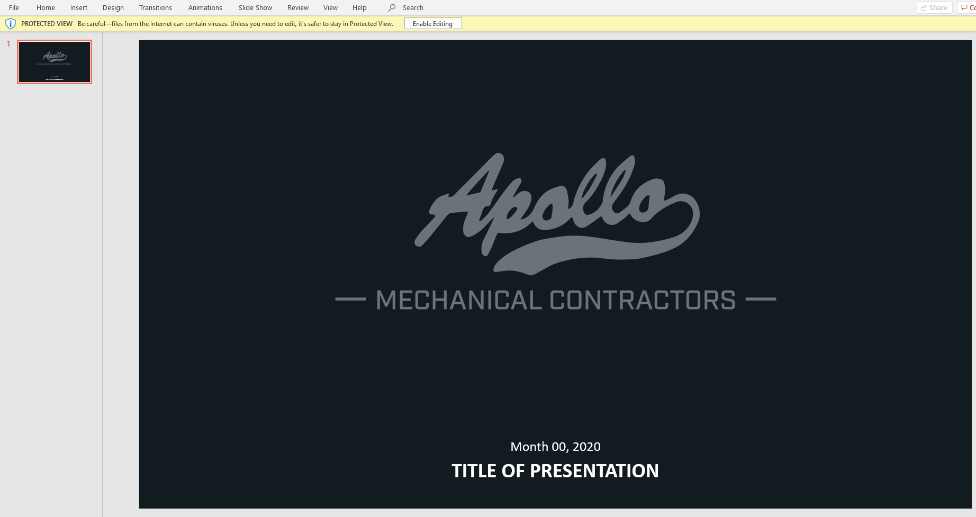
Multiple options have been created for virtually any layout scenario.

