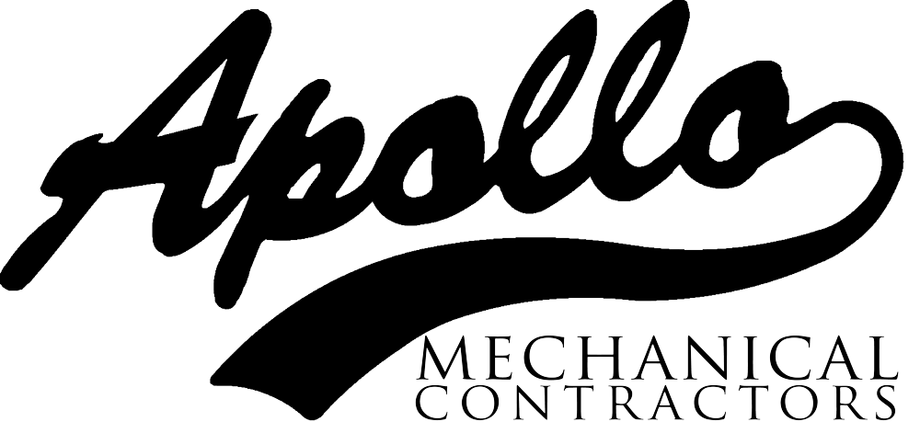

**Date: 7.29.2020**

**;**

**;**

**LKADF**

**Region: Portland**

**Project: MOD 3**

**Summary**

Crew was getting ready to pick a 15,000lbs air handling unit when our Journeyman Pipefitter, upon inspection noticed that multiple picking eyes located at the base of the unit had major damage. With the weights of the units and damage done to the picking eyes by the transporting company the crew and foreman made the call to cancel the planned hoisting of the unit until repairs are made.

**What Went Right?**

* Stop work Authority.
* Notified Foreman and Safety of the issues.
* Inspecting rigging and equipment that are going to be used during hoisting.

**What Went Wrong?**

* NOTHING!! Crew performed inspections as required per Apollo rigging and hoisting activities and found damage to the unit’s picking eyes and called off the hoisting.

**Lessons Learned**

* **Crew and others involved did a phenomenal job inspecting and speaking up when issues/damage were found to the unit.**
* **Keeping each other safe and going “Home Safe” is the culture we hold true. Seeing something, saying something, and doing something is a value best practiced and not preached.**
* **Good job crew!**

Good Catch