

**Date: July 09, 2020**

**;**

**;**

**LKADF**

**Region: Portland**

**Project: Intel MOD 3 Hillsboro**

**Incident Title: The Blind Side**

**Summary**

A Semi truck and lowboy trailer delivering an oversized load struck a handrail. While the truck and trailer were backing into position to be off-loaded by a crane, the driver was watching the spotter and could not see behind the equipment that he was hauling which was hanging over the side of the lowboy trailer. The spotter could not see both sides of the load and the blind side of the load hit a handrail that was anchored in concrete. The concrete cracked and the equipment was scratched.

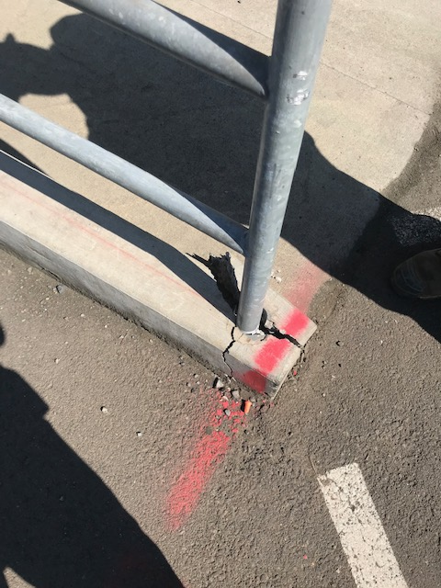

**What Went Right?**

* The incident was reported in a timely manner.
* Nobody was injured.
* Damage was minor
* The equipment was off-loaded safely

**What Went Wrong?**

* There was only one spotter used where there could have been at least two
* Workers had limited access to the work area due to security restrictions and were not able to assist the single spotter.
* The ability to use a different crane to offload in a less congested area was not considered.

**Lessons Learned**

* **Plan for to have an adequate number of qualified Spotters available when large deliveries are expected.**
* **Discuss the safest route of travel for the truck prior to the arrival.**
* **Consider alternate locations for off-loading if the area is congested.**

Lessons Learned