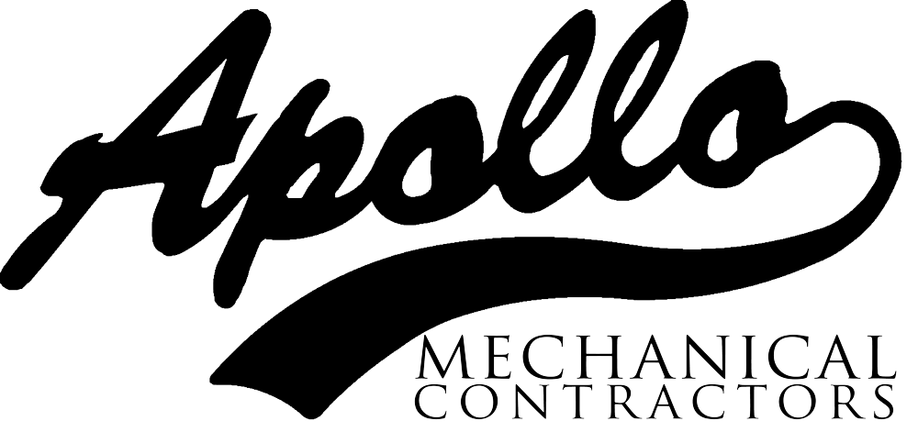

Duct that pinched employee

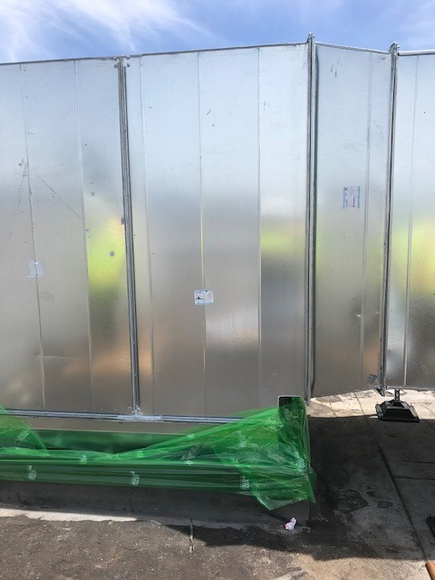

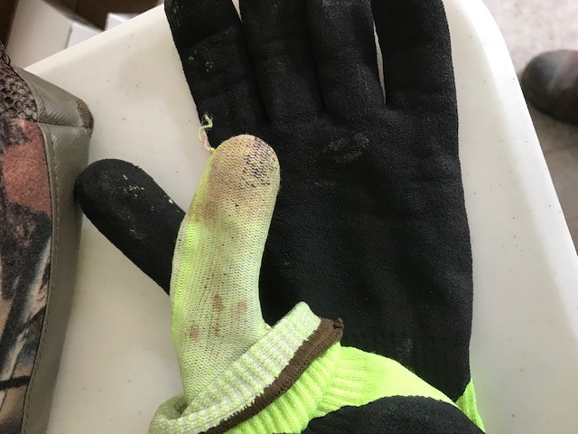

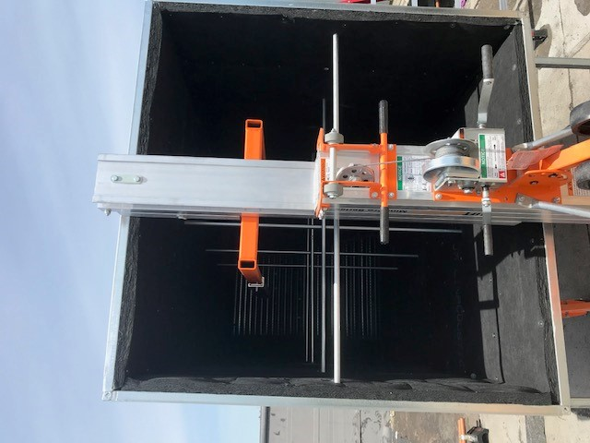

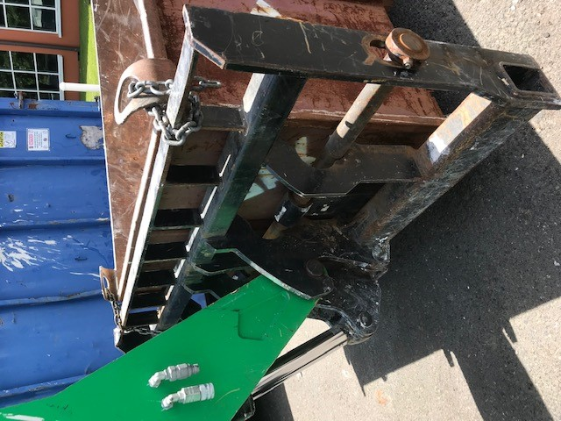

**Date: June 18, 2020**

**;**

**;**

**LKADF**

**Region: Portland**

**Project: Pacific Source**

**Incident Title: Crush injury to Thumb**

**Summary**

Worker was working in tandem with another worker loading duct material onto a forklift to hoist materials onto the roof.

While pulling a large piece of duct (72X48) onto the forks, the material slid toward the backrest of the forklift, pinching the employees’ thumb between backrest and duct.

**What Went Right?**

* Worker’s glove probably saved the end of his thumb - PPE can be a good thing.
* Worker reported the incident quickly.
* Medical clinic/Hospital location chosen at job startup, was very close to the job site.

**What Went Wrong?**

* Employees did not recognize the backrest of the forklift as a pinch point.
* Material was 300 lbs. and the hazard created by the weight/inertia of the moving material was not anticipated.
* Pulling, instead of pushing the material onto the forklift, created a “caught between” risk.

**Lessons Learned**

* **Workers had put pinch points on the PTP as a hazard item to watch.**
* **There needed to be more evaluation of the task as the day went on, to eliminate the “caught between” risk that was avoidable by simple pushing the material onto the forklift, instead of pulling it.**
* **Workers in tandem need to be more aware of partners hand and body positioning especially when moving large or awkward materials. MORE EYES = BETTER VISION resulting in RISK AVOIDANCE**

Lessons Learned