

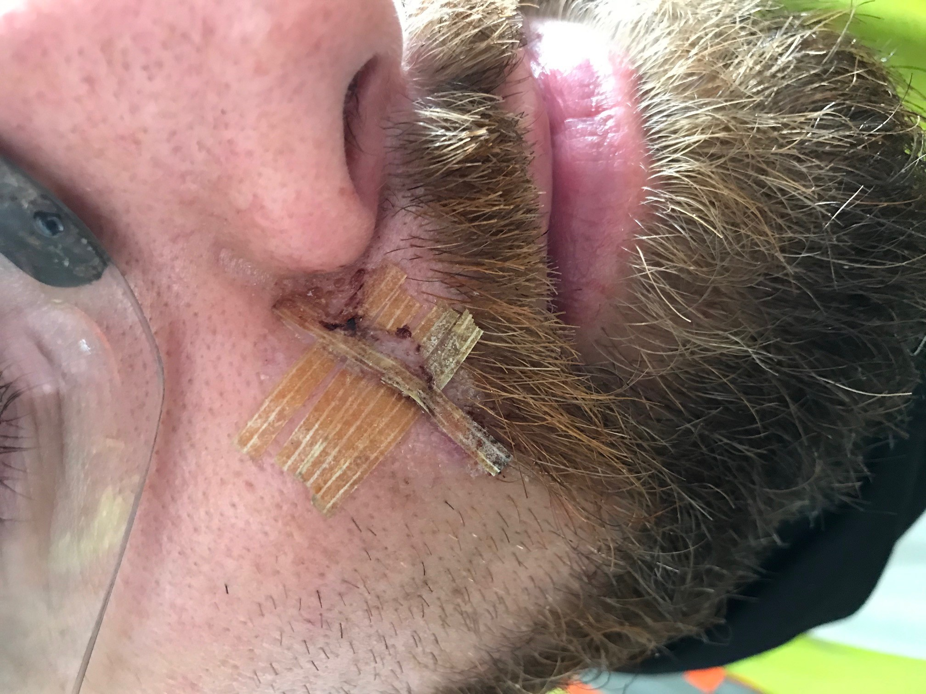

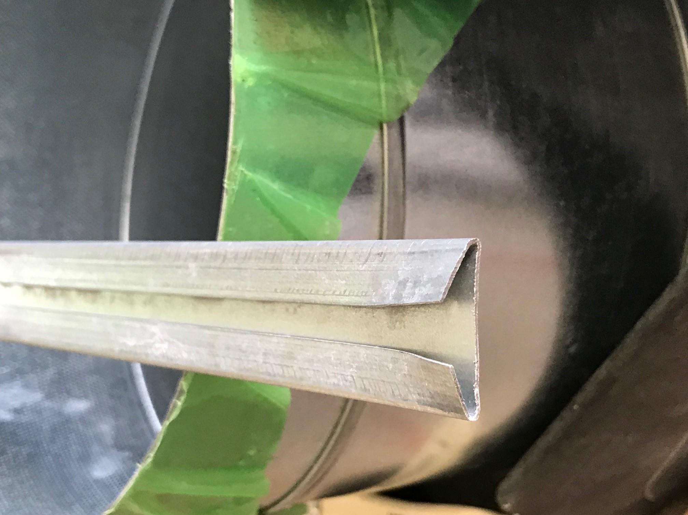

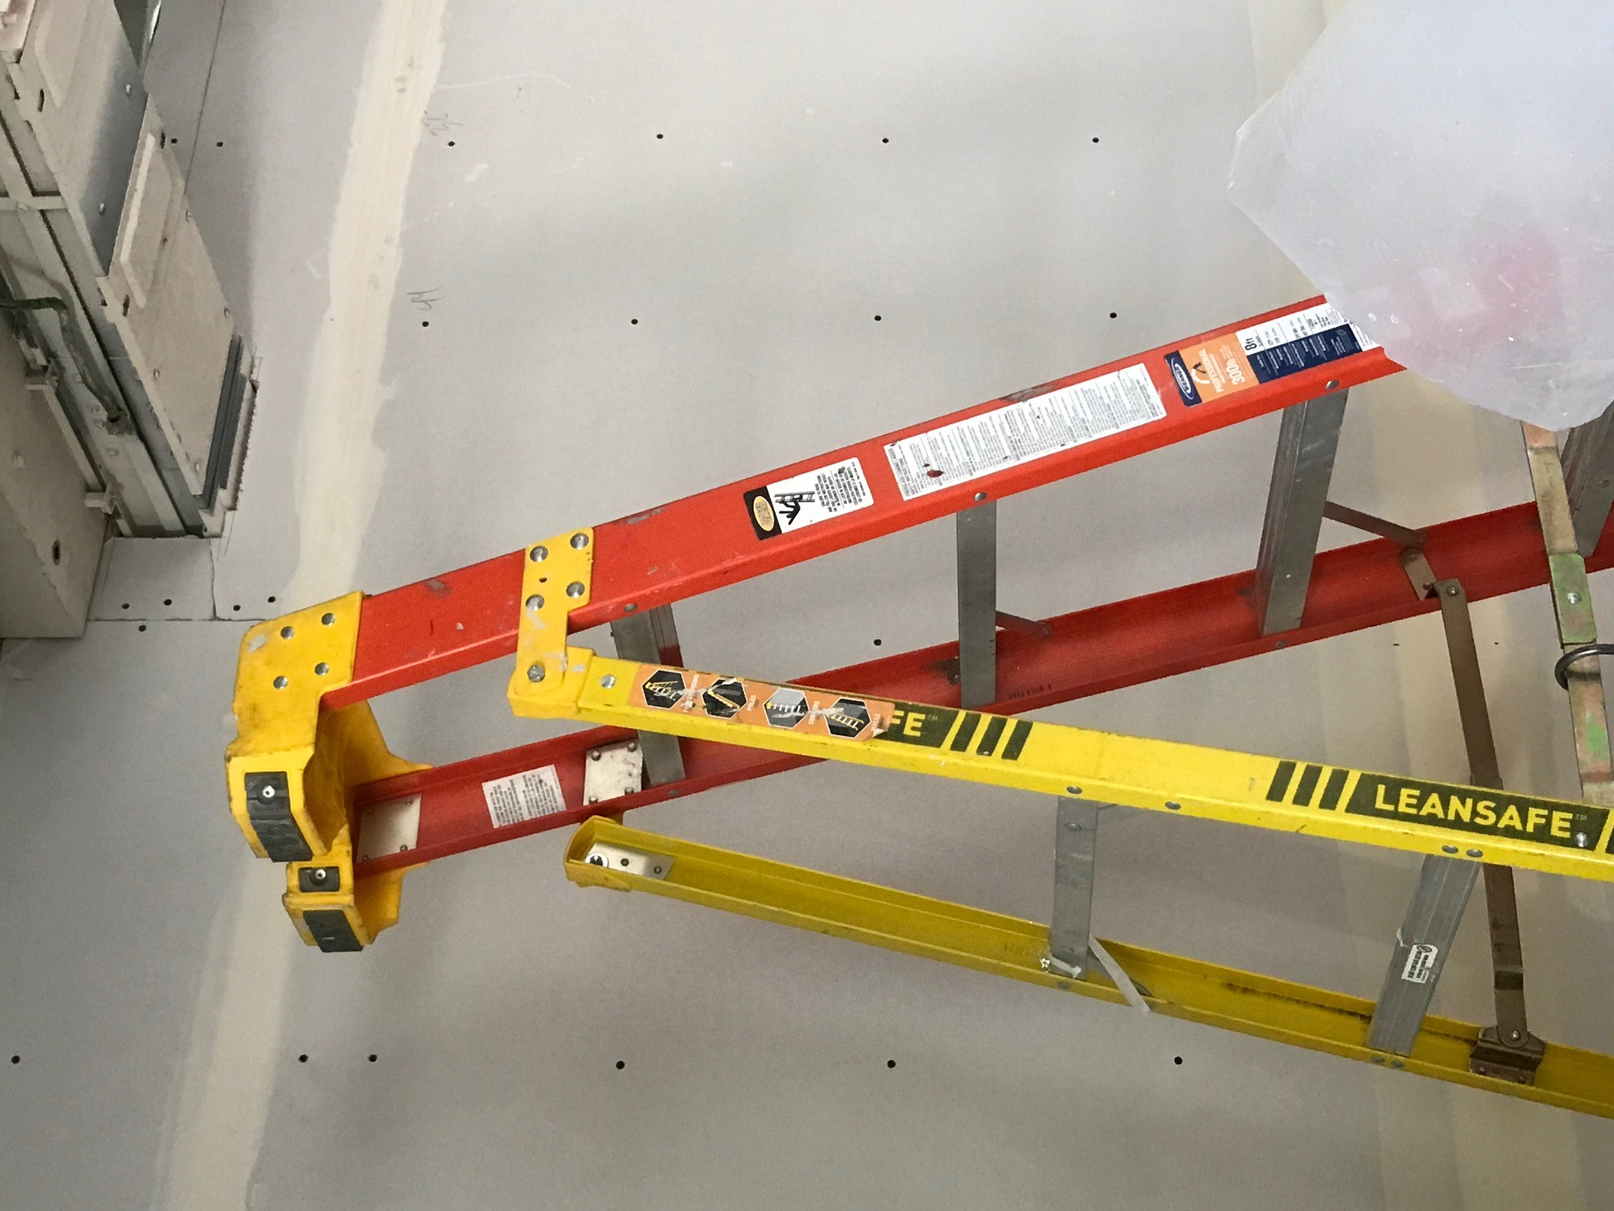

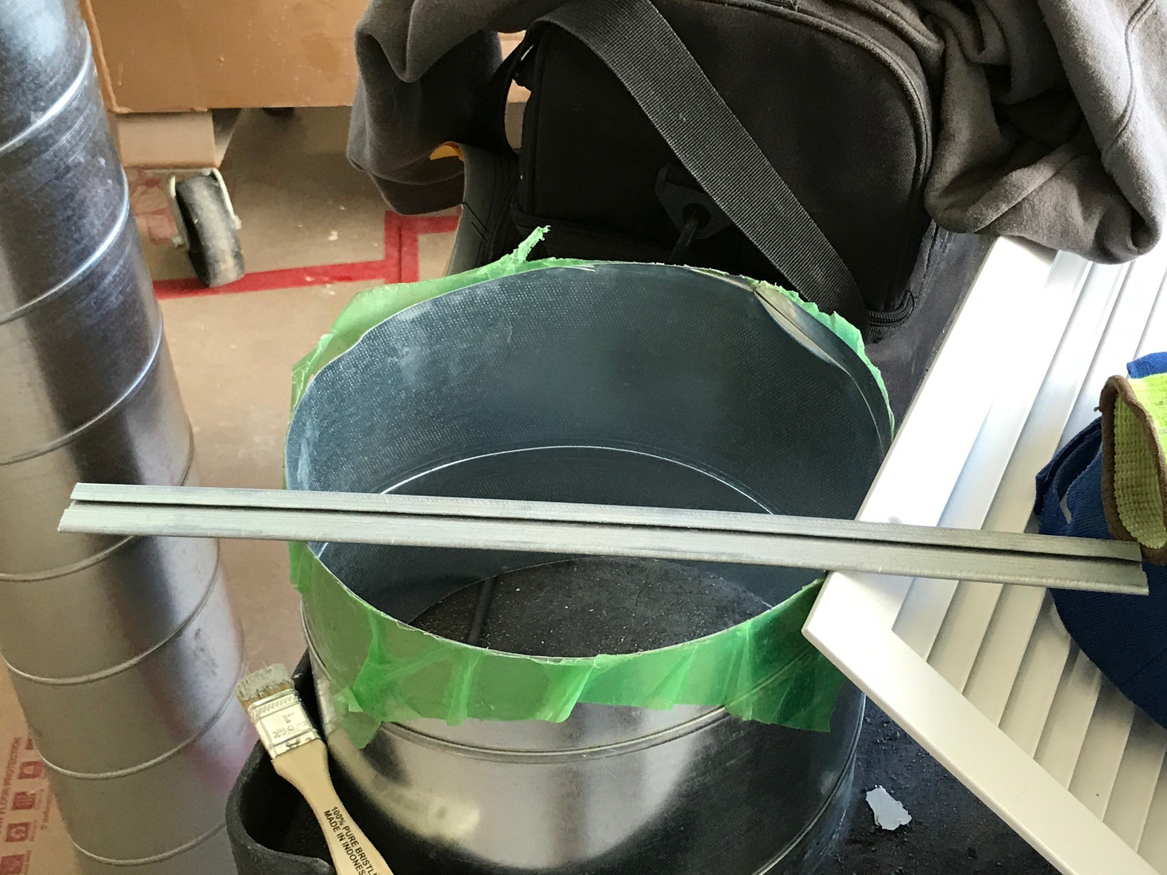

Material was left up here

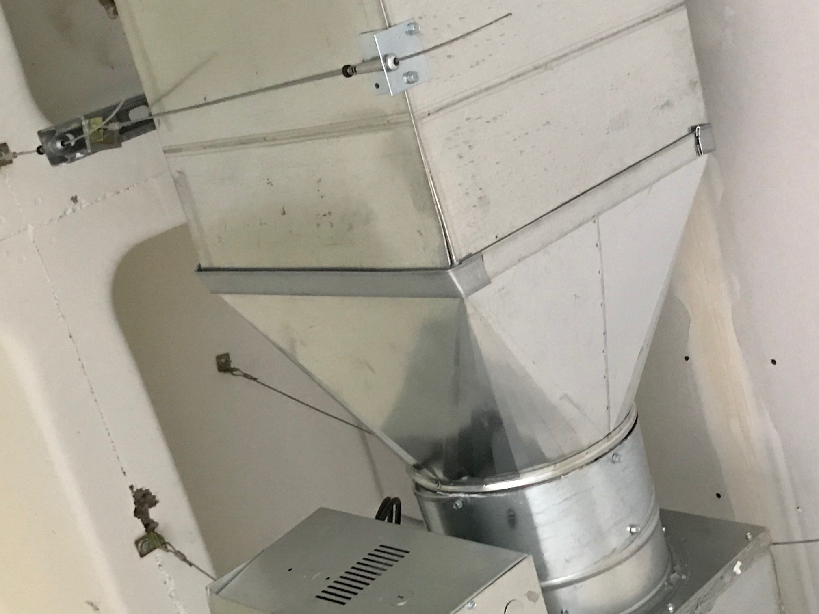

**Date: 6-1-20**

**;**

**;**

**LKADF**

**Region: Portland**

**Project: Klamath Hall**

**Incident Title: Falling material**

**Summary**

Employee was working on installing duct.

After installing sections of duct and retainers for them, he needed to move his ladder to get into a better position to caulk the seams.

When moving the ladder, he struck the duct, dislodging some leftover material that had been left on top of the recently installed duct.

This piece fell, striking employee in the right cheek, causing a small laceration.

**What Went Right?**

* Employee promptly reported incident
* Incident was not as serious as it could have been
* Employee was wearing all required PPE

**What Went Wrong?**

* Employee did not need the materials that were left on top of the duct work
* Excess materials were unsecured
* Employee did not recognize the hazards of the potentially falling material

**Lessons Learned**

* **Plan the work for adequate tools and materials. Use your PTP as a reference to make sure you have everything you need.**
* **Only take to elevation the tools and materials you need. Leave excess materials and tools on the ground, or have someone assist with handing you materials as needed.**
* **Personnel falls from elevation are not the ONLY hazards of working at height. Gravity always wins.**

Lessons Learned