TRASH BUGGIES WITH CASTERS!

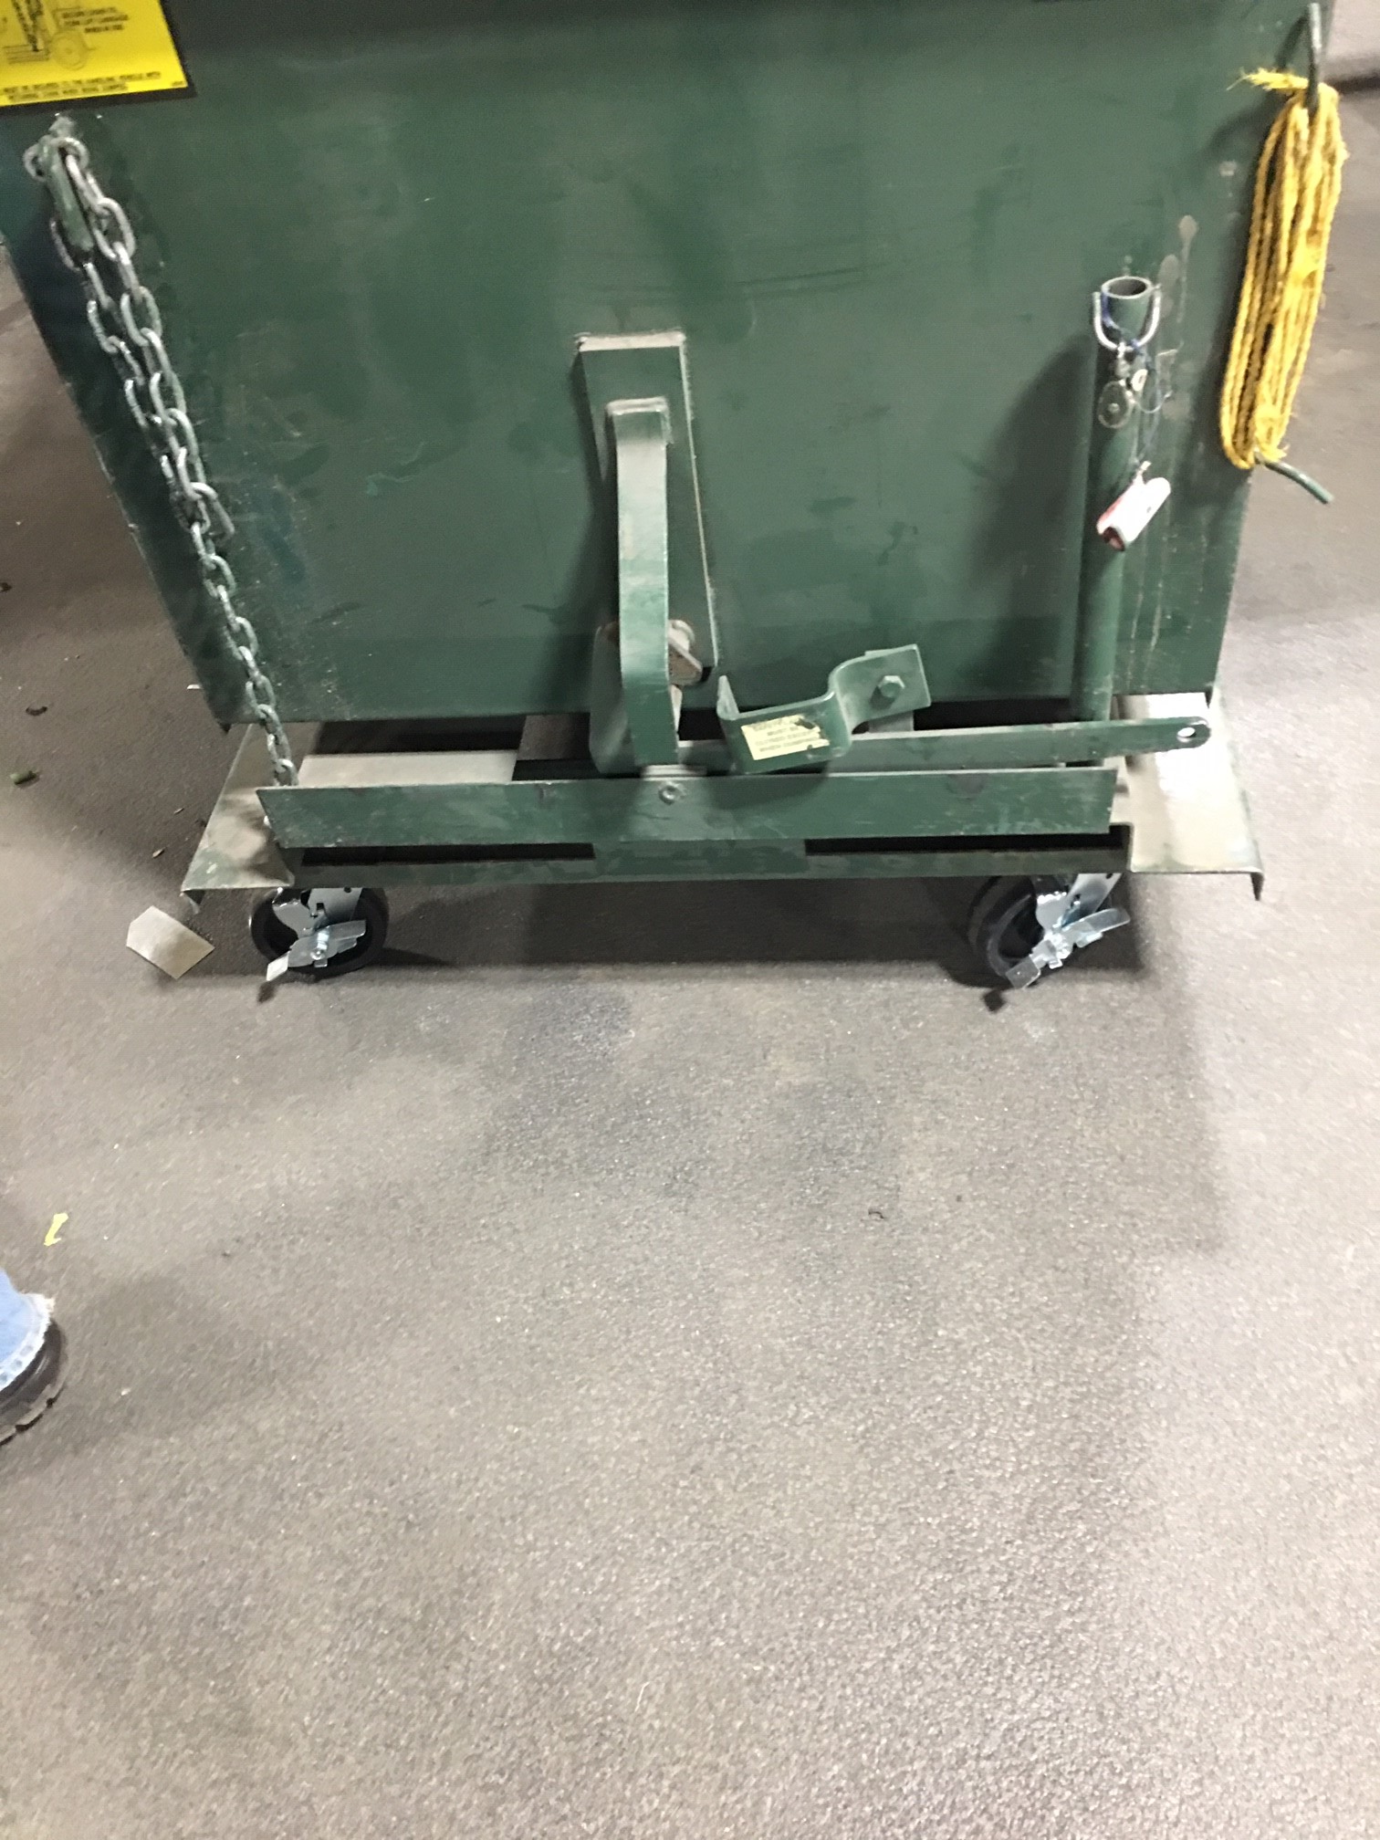

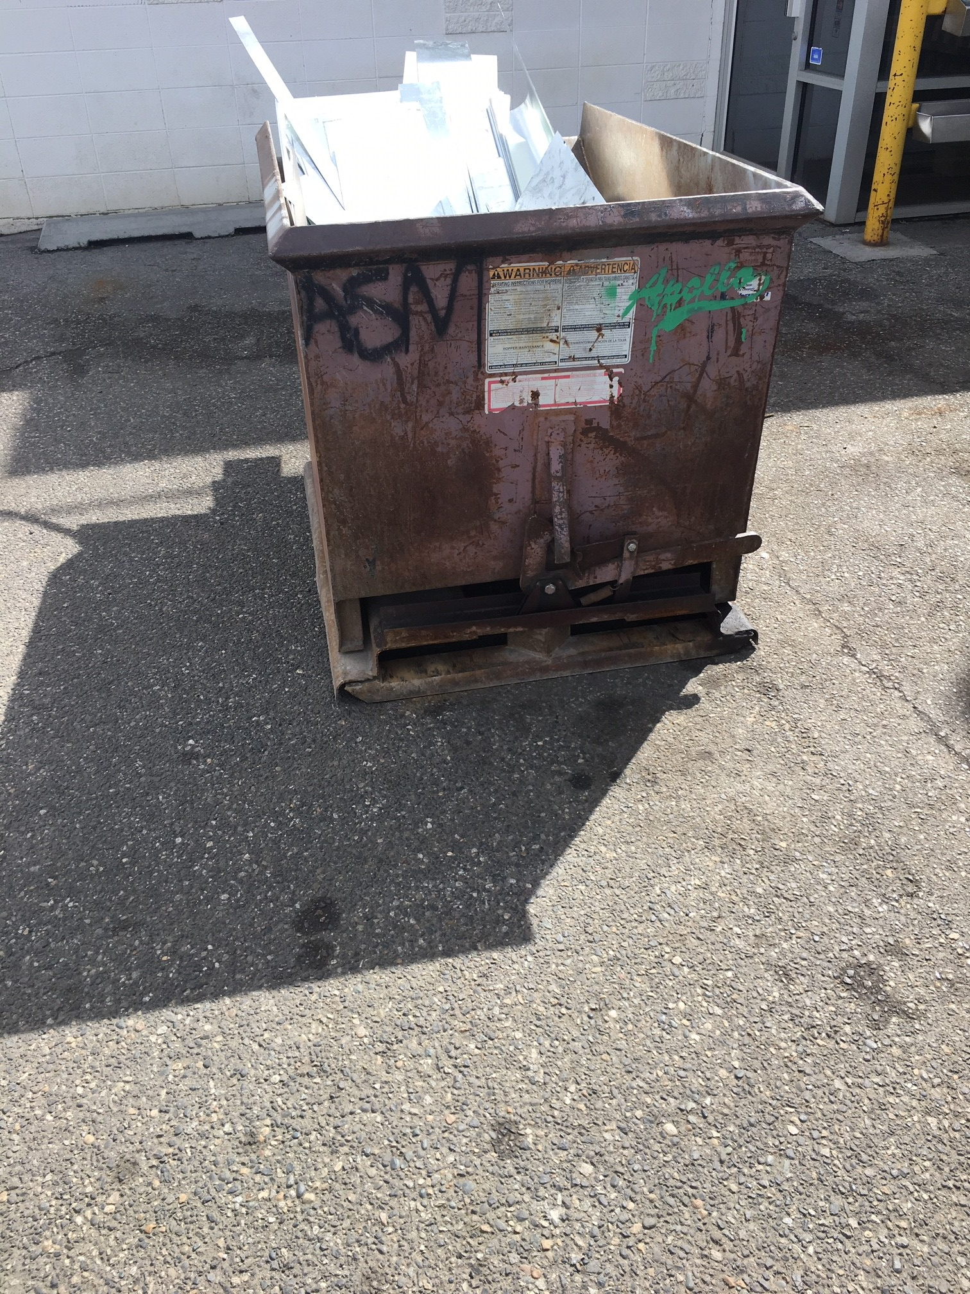

* CAN ONLY BE MOVED WITH FORKLIFT
* CAN’T ALWAYS BE PLACED NEAR WORK LOCATIONS
* DOESEN’T REQUIRE FORKLIFT TO PLACE
* REMOVES FORKLIFT FROM CONGESTED AREA
* PUTS TRASH BIN CLOSE TO WORK ACTIVITIES