Gauge Cage Hanging Racks

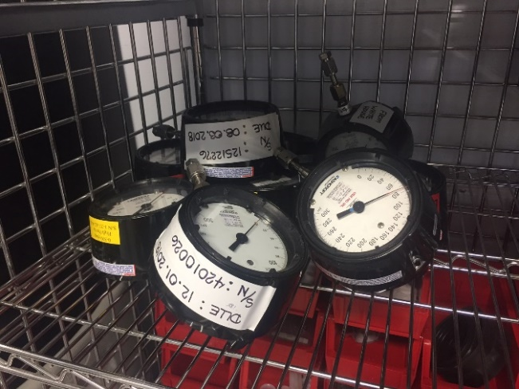 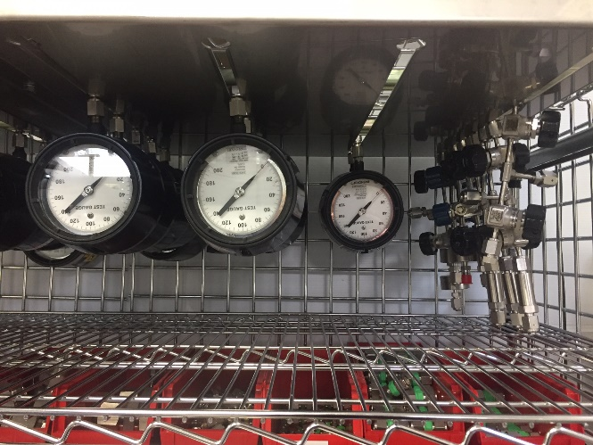

* Testing gauges would get checked out when a team needed to test systems in the field. Time and energy went into searching through the gauges to find the correct one for the job.
* Once the gauges were returned there was no organization so they didn’t have a specific home. The gauges were always mixed together.
* Kyle Vehrenkamp came up with an idea to hang the gauges so they wouldn’t get damaged and would be easy to organize. Each row is for a specific item broken down by PSI and type.
  + **(Wasted Motion)** – wasted motion looking for the specific gauge need to complete the job.
  + **(Wasting Time)** – wasted time digging through a pile of gauges trying to find the correct PSI needed.
  + **(Wasted Potential)** – Wasted employee genius spending time looking through gauges when they could be setting up for a test.