Sheet Metal Stock Bin

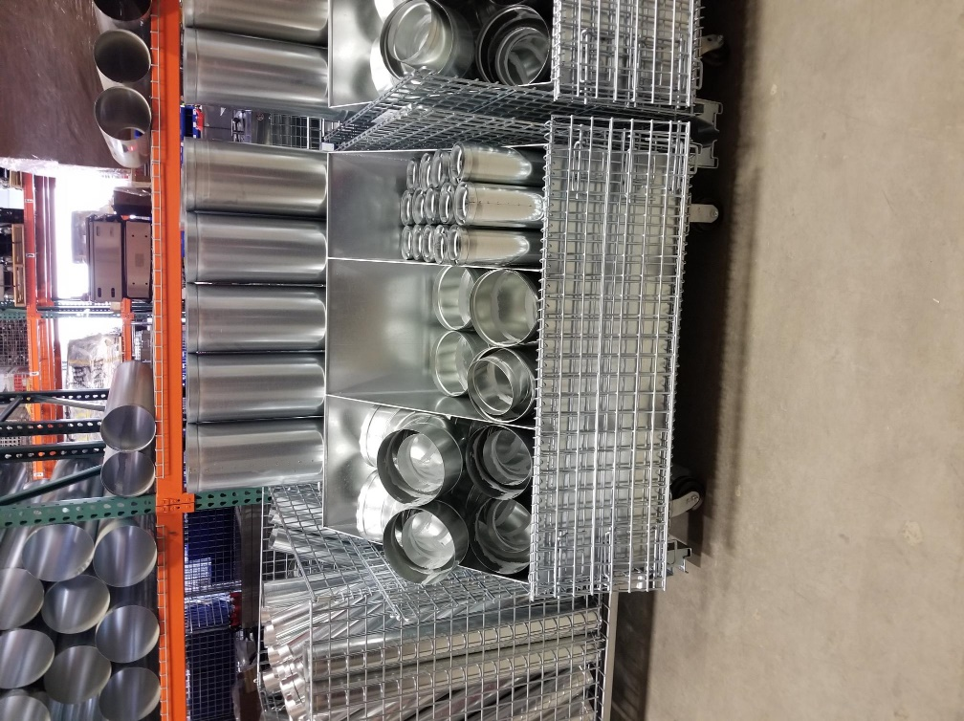

* Built dividers and changed the container style to allow for easier access and better segregation by size and fitting type.
  + **(Eliminates: Waiting) –** Parts can be found quicker and restocked better because it’s visually easier to find.
  + **(Eliminates: Excess Inventory & Over-Production)** – Less parts need to be fabricated because more parts can be found.
* Fittings of many different sizes and types stored in a single bin with no dividers
  + Created a wasteful process when looking for a specific fitting