**Lean Shark Cages**

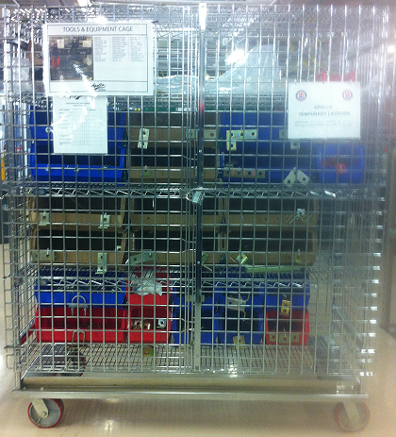

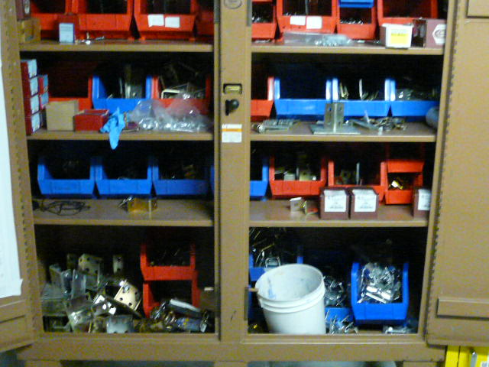

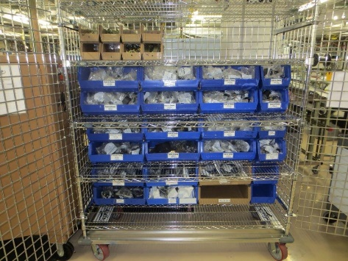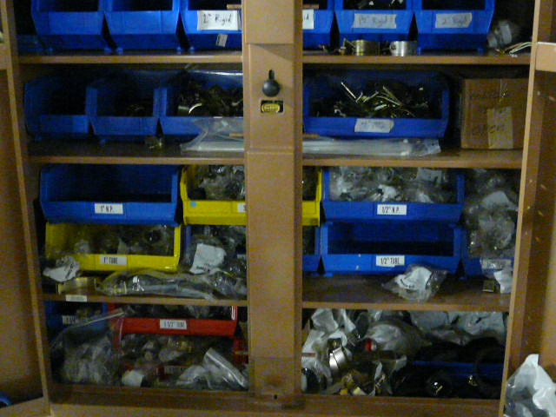

* Items are not organized
* Hard to find
* Can’t tell if what you need is available
* **(Eliminates: Waiting, Wasted Motion, Inventory, Transportation) –**
* Items have been 3S’d
  + Sort:
    - Only the items need are in the cage.
  + Straighten
    - Wire rack used so you can see what is in the cage without going into it
    - All items are in bins
  + Sustain
    - All items are labeled
    - Picture on front to show expectations