LEAN QC Cart

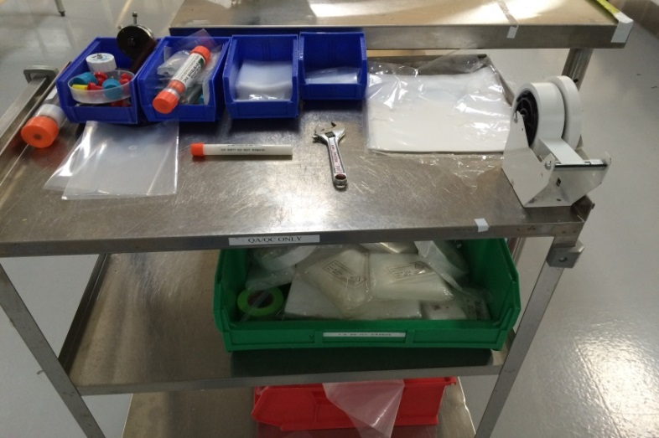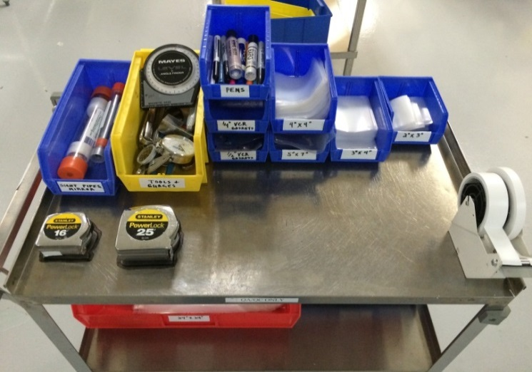

Place **AFTER** picture here

Place **BEFORE** picture here

* Cart was unorganized
* Have inspection tools and different size bags scattered on the cart
* Time consuming to find the correct tool or bag
* All bags are binned and organized by size
* Tools are binned and organized
* Location for components shadowed on the cart for easy identification