**Lean Pipe Vise**

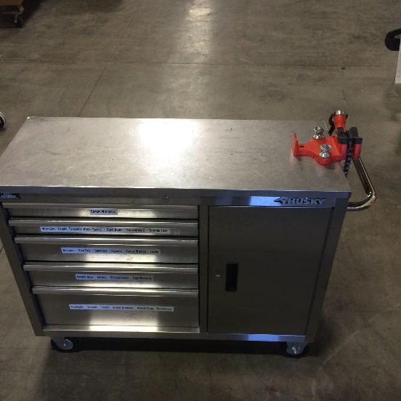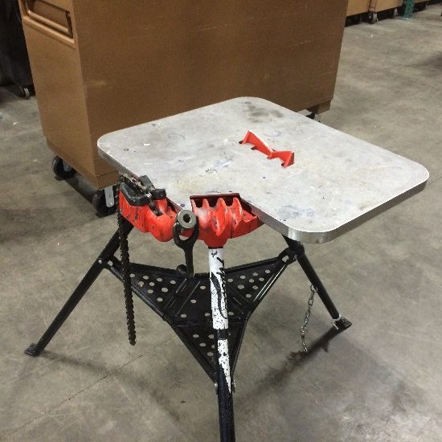

* Pipe vice was added to existing foreman’s tool box.
  + **(Eliminates: Wasted Movement)** Less items to move around and store. No set up time.
  + **(Eliminates: Waiting)** Always on hand- never have to look for it.
  + **SAFER**
* Pipe vice was big and bulky. A separate table had to be added to the vice to allow for working surface.
* The awkwardness of the assemble unit can lead to injuries.

Place **BEFORE** picture here