**Lean 1” Purge Fitting**

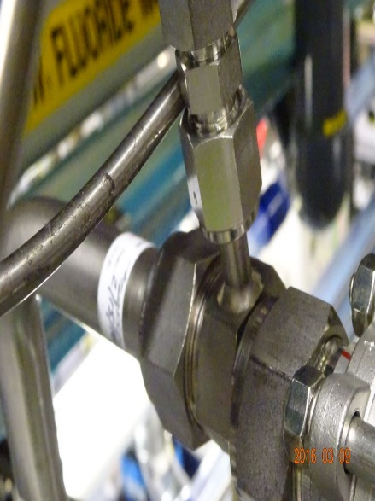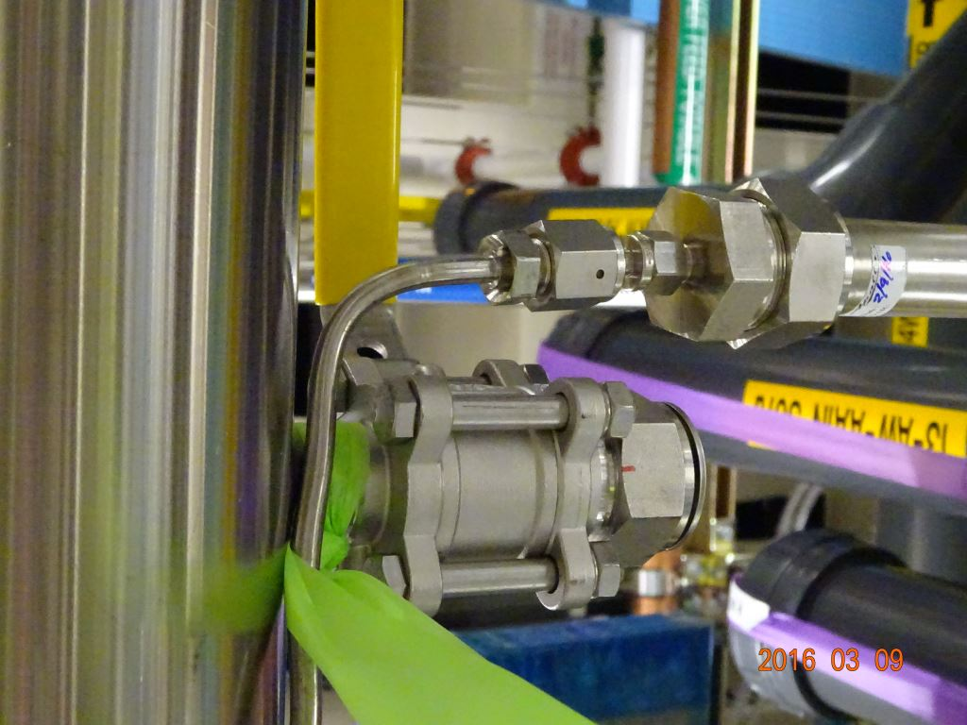

* In order to connect a purge to a 1” OFA line the clamps have to be removed from the first group of hangers so the spool can be pushed out of alignment with the LPOC.
* This causes the spool to be torqued and inability to “proof” to spool for fit.
* A new purge fitting was designed with the connection coming out of the side instead of the end allowing for the spool to be alignment with the LPOC
  + **(Eliminate: Wasted Motion)**- No longer have to go up into the racks to remove clamps in order to hook up the purge.
  + **(Eliminate**: **Defects)-** The spool can be alignment with the LPOC making sure the spool fits prior to final hookup.