Non-Conductive Strut Hanger

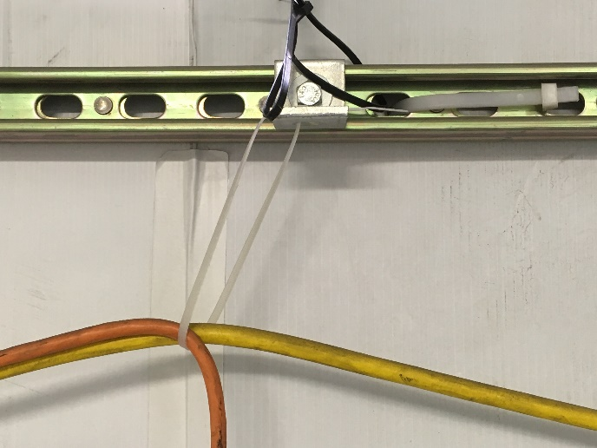

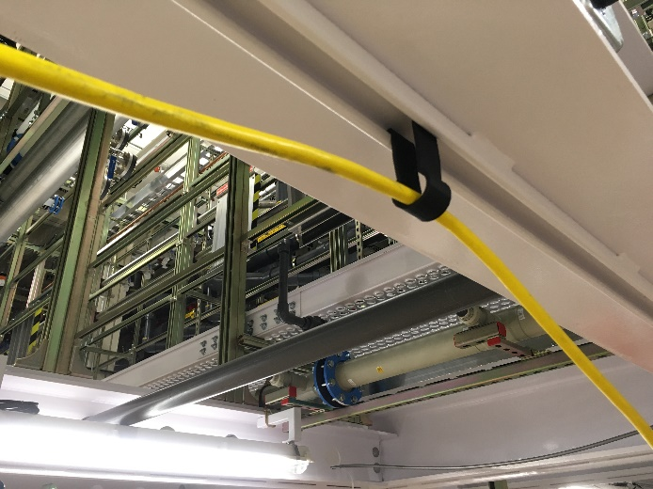

* Zip-ties are often used along with a 90 bracket to create a non-conductive hanger in strut channel.
  + Requires tools and a ladder to install & take-down
  + A strut fitting is required to provide a connection point for the zip-tie
* Created a 3D printed clip that inserts directly into strut channel and requires no tools to install or remove.
  + **(Eliminates: Motion) –** Less movement is needed to accomplish the same task during setup and take-down.
  + **(Eliminates: Waiting)** – Because it takes less time to install, we’re able to move on to the desired task quicker.
  + **(Employs**: **Employee Skills)** – Problem was solved from field input and the clips are 3D printed by a field foreman.