**Lean Material Cart Modification for Dumbwaiter**

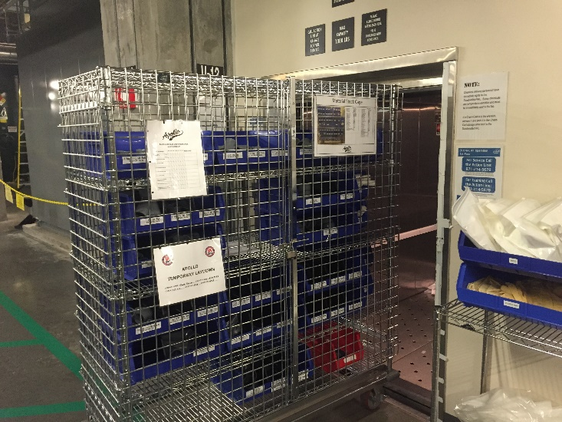

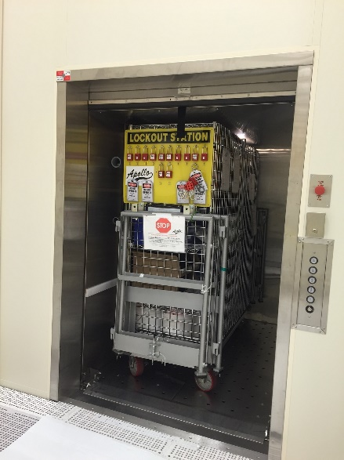

* All material cages have been cut down so we can easily move any material around the factory.
  + **(Eliminates: Waiting)**- for material while we wait for elevator
  + **(Eliminate: Wasted Motion)**- Putting things on smaller carts to utilize dumbwaiter, only to be put back into cage once it got into cleanroom
* Dumbwaiters are used to move material into clean room instead of the elevator because of long wait times with the elevator.
* Issue was our standardized material cages did not fit in the dumbwaiter.

Place **BEFORE** picture here