**Lean Label Tote**

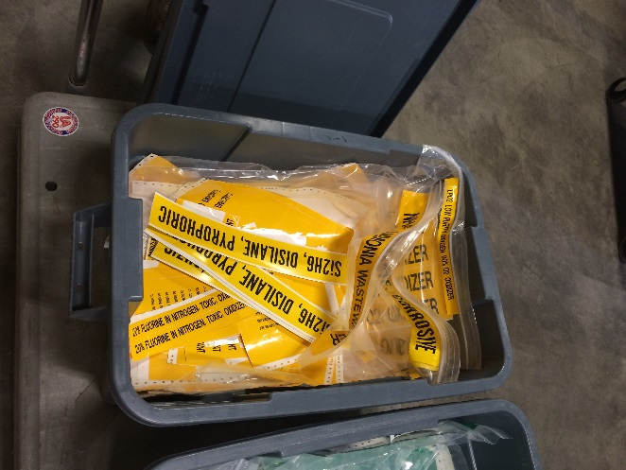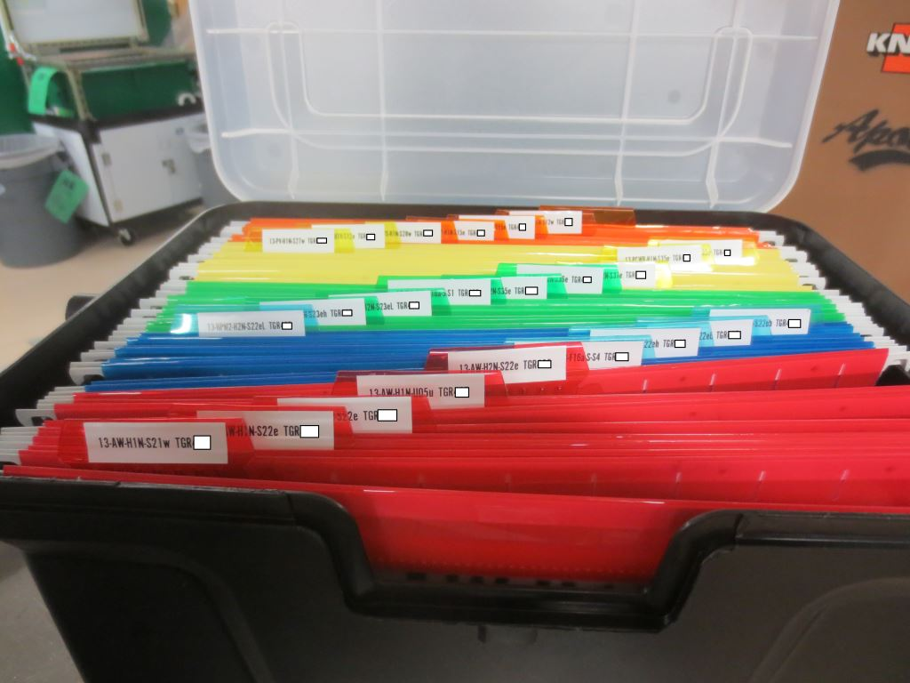

* Labels were ordered for an entire tool in no specific order.
* Orders were received all clumped together in a single bag from the vendor
* Foremen would receive the entire bag full of labels and would then sort through them as needed.
* Foremen would often place the entire bag in some type of container, unorganized, simply for containment.
* **(Eliminates: Waiting Time, Over-Production)** Orders are prepared and sent to the vendor in an organized manner.
  + The vendor prints and ships the order based on our order instructions.
* **(Eliminates: Wasted Motion, Waiting Time, Defects)** Once received we place the organized labels into a tote that is separated by reference numbers, which correlate to the drawing package.