**Specialized Tool Boxes**

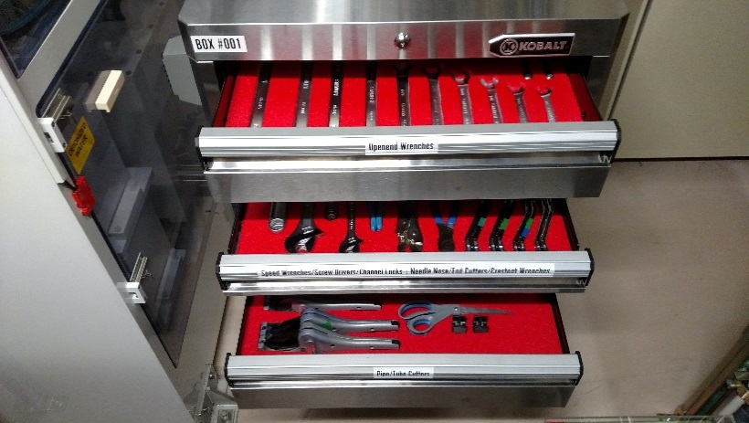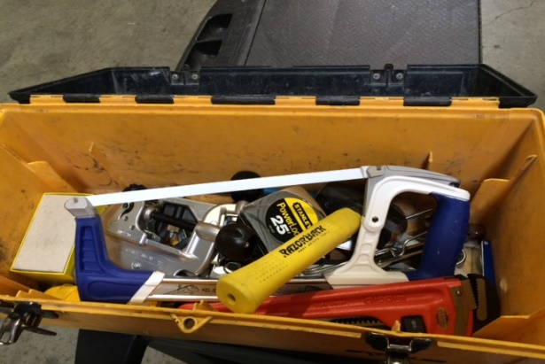

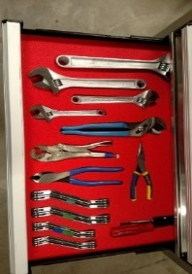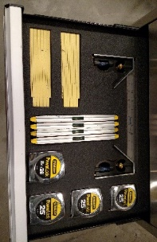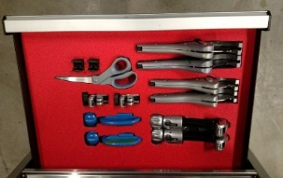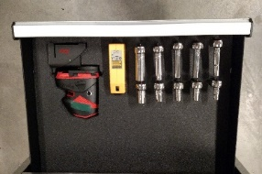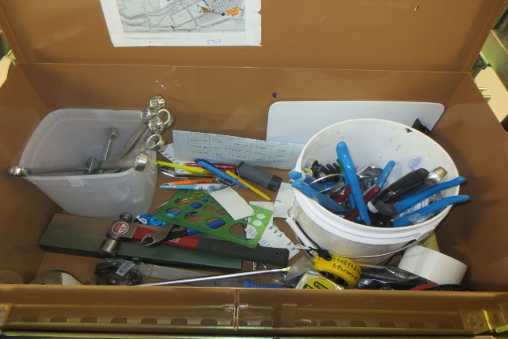

* **(Eliminates: Wasted Motion, Waiting Time)**
  + Tool box has been 3S’d
    - Sorted- Only tools that are needed
    - Straightened- Everything is organized
    - Sustained- Everything has a place
  + Standardized- Every crew has the same box so people moving from crew to crew know how to find things
  + Every socket has a drive
* **(Eliminates: Excess Inventory)**
  + Only the tools that are needed
  + A crew can share two tools instead of each person having their own box (6 of each tool)
* Tool box full of unorganized tools
* Dig through the box until the item needed was found

Place **BEFORE** picture here