LEAN Update

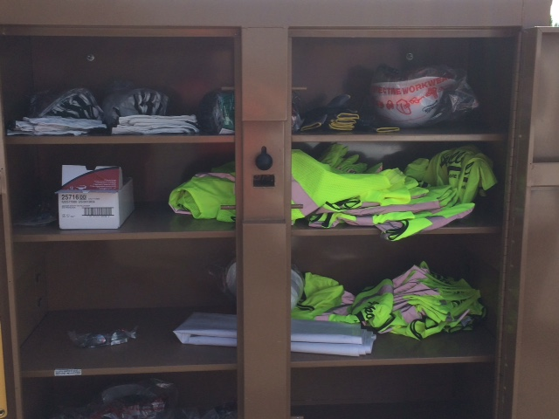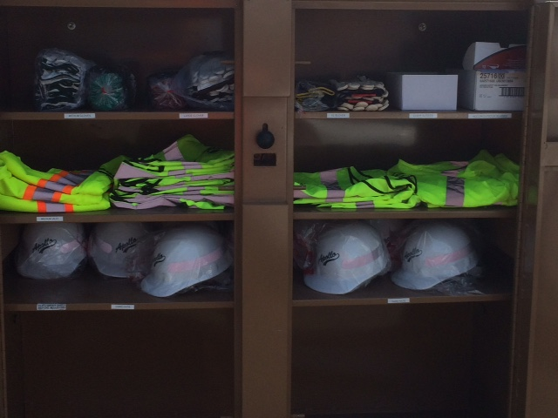

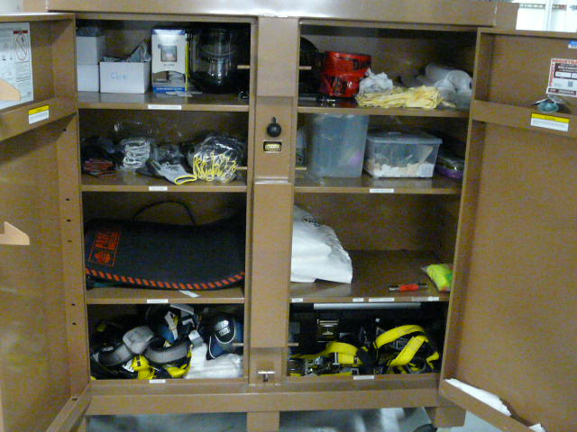

Safety equipment BEFORE

Unorganized and hard to locate needed items

Safety equipment AFTER

Organized and easy to locate needed items