Heat Exhaustion and Heat Stress Numbers

- Every person wakes up dehydrated. It is recommended a person should start their day by drinking at least 16 oz. of water before any daily activities begin.

- Pre- activity hydration is key. Starting any physical activity in the heat, when previously not fully hydrated increases the risk for soft tissue injuries dramatically. A decrease in hydration causes an increase in muscle exertion, elevated heart rate and blood pressure. 2% in weight loss caused by water loss results in an average of a 20% decrease in muscle performance of athletes.

- Most heat-stroke deaths in newly hot temperatures occur on Day 1 or 2. A similar 1-2 punch applies in the military. In studying 1,454 cases of heat illness in Marine-recruit training, researchers implicated heat stress on the prior day as a factor (Kark et al., 1996). So a prime time for heat stroke is the day after an exhausting and dehydrating day in the heat.

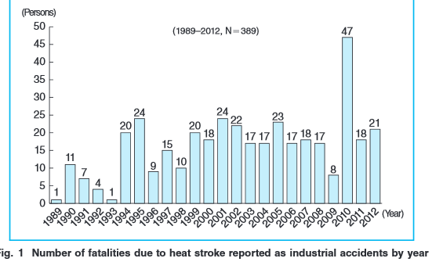
- A person’s muscle mass to fat % plays a role in heat stress. Extra fat is an extra load, increasing exertional heat production. Statistically speaking, bodies with higher fat content are harder to cool down than those with not as much.

- In 2006, which is the second hottest year that has ever been recorded, 3,100 US workers had a heat-related illness that caused them to miss work.

- According to the National Weather Service 10 year average for heat fatalities was 170 between 1998 and 2007.

Homemade Sports Drink Recipe #1
- 10 tbs. sugar (5/8 cups or 120 grams)
- .75 tsp Sea salt (4.2 grams) or Morton’s lite
- 1 package of unsweetened Koolade mix for flavor
- Water to make 2 liters
REMINDER: Pacific Northwest temperatures are an average of 20 degrees hotter than they have been in the past, at this time. Forecasted to remain in the temperatures over 100 degrees for the next 2 weeks.

