Apollo Glove Matrix
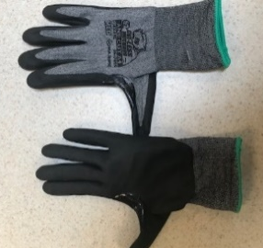 | Cut Resistant ANSI A4  For everyday use by Sheet Metal and Piping workers exposed to any sharp edges that must maintain high dexterity.  Majestic M6835-7465 -about $7.25/pr.
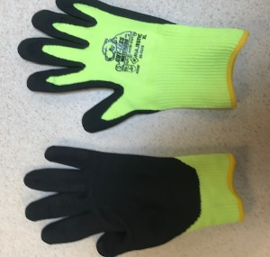 | Cut Resistant ANSI A6  For use by our material handlers who do not need higher dexterity and mainly move material.  Majestic M6835-7676 – about $6.00/pr.
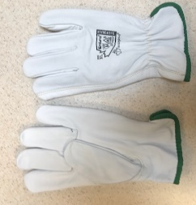 | Cut Resistant ANSI A4 –fire-resistant goat skin glove. Arc rated 36 CAL/CM.  For use by personnel who are exposed to hot work and sharp objects.  Endura #378GKTFG – about $14.70
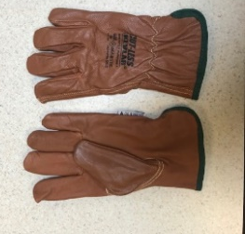 | Cut Resistant ANSI A4 – Water, oil, and fire-resistant goat skin glove. Arc rated 36 CAL/CM  For use by personnel who work in oily and wet environments, also exposed to hot work and sharp objects.  Keystone #M681555WRK - $16.00/pr,
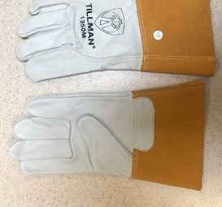 | Welding/hot work only. No Cut Rating!!  Tillman welding glove – About $8.00/pr
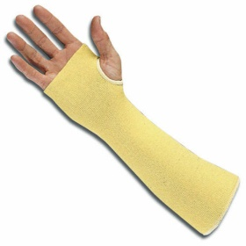 | Cut 4 sleeves – Used anytime when working within (touching) distance of sharp edges sleeves must be worn.  Cut 4 Sleeve – about $3.00/each

