.1.0 Purpose

1.1 To establish the requirements, responsibilities, and procedures for protecting personnel engaged in the use of rigging equipment during rigging operations. Furthermore, the purpose of this policy is to ensure compliance with the Federal and State Regulations.

2.0 Responsibility

  - The Key Supervisor shall be responsible for the ensuring compliance with this procedure.
  - Employees shall be responsible for complying with this procedure.

3.0 Definitions

  - Angle of loading- the acute angle between horizontal and the leg of the rigging, often referred to as horizontal angle.
  - Basket Hitch- the method of rigging a sling in which the sling is passed around the load and both loop eyes or end fittings are attached to the lifting device.
  - Bird Caging- the twisting of fiber or wire rope in an isolated area of the rope in the opposite direction of the rope lay, thereby causing it to take on the appearance of a bird cage.
  - Braided wire rope- the wire rope formed by plaiting component wire ropes.
  - Choker hitch- the method of rigging a sling in which the sling is passed around the load, then through one loop eye, end fitting or other device, with the other loop eye or end fitting attached to the lifting device. This hitch can be done with a sliding choker hook or similar device.
  - Come-a-long- a mechanical device typically consisting of a chain or cable attached at each end that is used to facilitate movement of materials through leverage.
  - Competent Person- means one who is capable of identifying existing and predictable hazards in the surroundings or working conditions which are unsanitary, hazardous, or dangerous to employees, and who has authorization to take prompt corrective measures to eliminate them.
  - Dedicated Spotter (power lines) - a person who’s sole responsibility is to watch the separation between the power line and the equipment, load line and load (including rigging and lifting accessories), and ensure through communication with the operator that the applicable minimum approach distance is not breached.
  - Fall Zone- the area (including but not limited to the area directly beneath the load) in which it is reasonably foreseeable that partially or completely suspended materials could fall in the event of an accident.
  - Lifting Device- Any machine or device used to lift a load, including but not limited to a crane, hoist, forklift, chain fall, come-along, jack, jacking system, derrick, monorail hoist, gantry crane, or pulley system.
  - Rated capacity- means the maximum working load permitted by the manufacturer under specified working conditions. Such working conditions typically include a specific combination of factors such as equipment configuration, radii, boom length, and other parameters of use.
  - Rigging- Any material used to attach loads including but not limited to: chain, wire rope, synthetic slings, and miscellaneous hardware.
  - Site Supervisor- Controlling organization supervisor that has control over the work site that the crane is being used in and over the work that is being performed at the site.
  - Sling- the assembly to be used for lifting when connected to a lifting mechanism. The upper portion of the sling is connected to the lifting mechanism and the lower supports the load.
  - Qualified Person- A person who by possession of a recognized degree, certificate or professional standing, or who by extensive knowledge, training, and experience, has successfully demonstrated his/her ability to solve or resolve problems relating to the subject matter, the work, or the project.
  - Qualified Rigger- A person, who by possession of a recognized degree or certificate of professional standing, that is within the fall zone and hooking, unhooking, guiding a load, or doing the initial connection of a load to a component or structure who understands and demonstrates knowledge of the hazards and controls associated with rigging operations.
  - Qualified Signalman- A person that is giving any signals to a crane/derrick operator and that has met the qualification requirement in the latter part of this policy.
  - Working load- the external load applied to the hoisting equipment, including the personnel lifting platform, its contents, and the load attaching equipment, such as lowered load block, shackles, and slings.

4.0 Personal Qualifications and Responsibilities

  - Qualified Rigger

    - Required whenever workers are within the fall zone and hooking, unhooking, or guiding a load, or doing the initial connection of a load to a component or structure.

    - Each qualified rigger must:

      - Must know and understand the requirements for slings, rigging hardware, and below-the-hook lifting devices, including their limitations, rigging practices, associated hazards and inspection requirements.

      - Be able to communicate effectively with the crane operator and signalman.

      - Know and understand the application of the type of slings and hitches used.

      - Know and understand load weight estimation, center of gravity, effect of angles on rigging components, load turning, chain hoists usage, and basic hand signals, as applicable.

      - Know and understand environmental hazards

      - Must demonstrate that they meet these requirements through a written test. All tests shall be documented.

    - Rigger certification cannot exceed a 5-year period; this qualification must be renewed every 5 years to ensure rigger maintain qualified status. At a minimum, this renewal must include a documented written exam.

  - Qualified Signalman

    - Each Signalman must:

      - Know and understand the type of signals used.

      - Have a basic understanding of crane/derrick operation and limitations, including the crane dynamics involved in swinging and stopping loads and boom deflection from hoisting loads.

      - Demonstrate that they meet these requirements through an oral or written test and a practical test. All tests shall be documented.

    - Qualifications must be renewed every 5 years. At a minimum, this renewal must include a documented written or oral or practical exam.

5.0 General Requirements

  - All rigging activities shall be performed by a qualified rigger or performed under the direction and supervision of a qualified rigger.

  - All rigging gear must be used in accordance with the manufacturer’s recommendations.

  - Rigging and lifting a load from an excavator shall be from the picking point designated by the manufacturer.

  - The rated load of the rigging equipment must not be exceeded.

  - Rigging equipment, when not in use, shall be removed from the immediate work area so as not to present a hazard to employees.

  - When the operator has a stationary suspended load, no employee is allowed to be within the fall zone except those engaged in hooking, unhooking or guiding the load or are engaged in the initial attachment of the load. Only employees needed to receive a load are permitted to be within the fall zone when a load is being landed.

  - No employee shall travel under a suspended load.

  - Where available, load swing path that minimize the exposure of employees to hoisted loads must be used to the extent consistent with public safety.

  - Workers must keep all parts of their body from between the load and any rigging during the lift.

  - Prior to starting lift the operator and rigger shall check that:

    - The hoist rope is not kinked;

    - Multiple-part lines must not be twisted around each other;

    - The hook must be brought over the load in such a matter as to minimize swinging;

    - That all slack in the rigging is removed; and

    - Load is not caught or attached to anything

  - The rigger must verify that the load is within the rated capacity of the crane.

  - The operator must not leave the controls while the load is suspended.

  - Tag lines must be used when rotation or swinging of the load is hazardous or if the load needs guidance.

6.0 Inspection and Maintenance

  - All rigging equipment shall be inspected prior to each use, and periodically throughout each use, by a competent person.
  - All rigging found to be unsatisfactory must be removed from the jobsite and disposed of, or tagged and marked out of service and not to be used for load bearing activities.

7.0 Rigging Hardware

  - General

    - All rigging hardware in use must meet the applicable requirements for design, inspection, construction, testing, maintenance and operation as prescribed in ASME B30.26-2010.

    - All hooks in use must meet the applicable requirements for design, inspection, construction, testing, maintenance and operation as prescribed in ASME B30.10-2009.

    - All below-the-hook lifting devices in use must meet the applicable requirements for design, inspection, construction, testing, maintenance and operation as prescribed in ASME B30.20-2010

    - Hooks and other rigging hardware must not be modified by welding and/or drilling.

    - Rigging hardware must be removed from service when it shows one or more of the following:

      - Missing or illegible identification
      - Indications of heat damage, including weld spatter or arc strikes
      - Excessive pitting or corrosion
      - If load bearing components are bent, twisted, distorted, stretched, elongated, cracked, or broken
      - Excessive nicks or gouges
      - 10% reduction of the original dimension at any point
      - Excessive thread damage or wear
      - Evidence of unauthorized welding or modification
      - Any other conditions that cause doubt as to the safety of continued use
      - On shackles- inspect for incomplete pin engagement
      - On swivels- check for lack of ability to freely rotate or pivot; check for loose or missing nuts, bolts, cotter pins, snap rings, or other fasteners
    - Any alteration or modification of rigging hardware must be in accordance with manufacturer’s recommendations and have a documented proof load tested to 125%.

    - Replacement parts must meet or exceed the original rigging hardware manufacturer’s specifications.

    - Rigging hardware selection must have the characteristics suitable for the application and the environment where it will be used.

    - No open hooks shall be used to hoist a bucket, cage, spreader, or skip, nor in any circumstances where the dislodgment of the hook could cause risk of injury to workers. A safety-hook, moussing, or shackle shall be used in such circumstances.

    - When shackles are used, shackle pins shall be secured to prevent accidental withdrawal.

  - Shackles

    - Use marked shackles that have manufacturer, rate load and size stamped into it.

    - Pins must be connected to the choking eye of the sling when a shackle is used in a choker hitch.
    - Screw pins must be fully engaged, with the shoulder in contact with the shackle body; rigged in a way that keeps the pin from unscrewing while use; and secured from rotation or loosening if used for long-term installations.

    - Cotter pins must be kept in good working condition.

    - If the shackle is side loaded, reduce the rated load according to the recommendations of the manufacturer or a qualified person.
(See Figure 1.)

Figure 1

Side Loading
Side Loading Angle, deg. | % Rated Load Reduction
In-line 0 to 5 | None
6 to 45 | 30%
46 to 90 | 50%
Over 90 | Not permitted unless authorized by manufacturer or qualified person
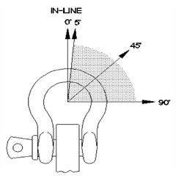

  - Eye bolts

    - Eye bolts shall only be used for single point picking. Side loading reduces the rated load. (See Figure 2)

    - If more than a single point is needed swivel eye bolts shall be used.

Figure 2

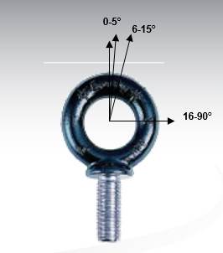
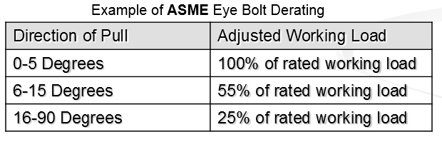

8.0 Slings

  - All slings in use must meet the applicable requirements for design, inspection, construction, testing, maintenance and operation as prescribed in ASME B30.9- 2010.

  - Chain Slings

    - Chains used for overhead lifting shall be proof tested and made from 80 grade or higher alloy steel chain.

    - Welded alloy steel chain slings shall have permanently affixed durable identification stating size, grade, rated capacity, length (reach), number of legs, individual sling identification (serial number), repairing agency
(if sling was ever repaired), and sling manufacture.

    - Hooks, rings, oblong links, pear-shaped links, welded or mechanical coupling links, or other attachments shall have a rated capacity at least equal to that of the chain.

    - The use of job or shop hooks and links, or makeshift fasteners, formed from bolts, rods, etc., or other such attachments, shall be prohibited.

    - The practice of placing bolts, nails, or cold shuts between two links to shorten chains is prohibited.

    - Splicing broken chains by inserting a bolt between two links, or passing one link through another and inserting a bolt or nail to hold it is prohibited.

    - Chains shall be visually inspected when the chain is new and prior to each use and frequently through its use. Check for missing or illegible sling identification; visible damage such as cracks or breaks; excessive wear, nicks, or gouges; stretched chain links or components; bent, twisted or deformed links or components; evidence of heat damage or weld splatter, or excessive pitting or corrosion. A qualified person must inspect each chain periodically, examining each link and component individually, taking care to examine the inner ling surface. Periodic inspections shall be documented. Damaged chains shall be tagged and taken out of service.

    - Chains must have the ability to hinge freely.

    - Only the manufacturer or qualified person is permitted to repair chain sling. The Sling must be marked to show the repairing agency.

    - Replace cracked, broken, or bent chain links or components instead of repairing them.

  - Wire Rope Slings

    - Wire rope slings shall be inspected prior to each use and annually for slings in service. Check for missing or illegible sling identification; visible damage such as severe localized abrasion or scraping, kinking, crushing, bird caging, heat damage, or severe corrosion; end attachments that are cracked, deformed, or worn to the extent that the strength of the sling is substantially affected; 5 broken wires in one strand or 10 randomly distributed broken wires. The entire length of the sling, including splices, end attachments and fittings will be inspected. Records of periodic inspections will be kept on file.

    - You must not repair wire rope slings.

    - All wire rope slings must have legible identification information attached.
      - Name or trademark of manufacturer
      - Diameter or size
      - Rated loads for the types of hitches used and the angle that the load is based on
      - Number of legs, if more than one
      - Repairing agency, if the sling is ever repaired.

    - Wire rope which has been welded or has been subject to welding of any kind shall not be used.

    - Protruding ends of strands in splices on slings and bridles shall be covered or blunted.

    - Wire rope shall not be secured by knots.

Wire ropes must be used within the rated loads. The use of horizontal sling angles less than 30 degrees, unless recommended by the manufacturer, is prohibited. Slings made with wire rope clips must be used as a choker hitch.

    - Intentional shock loading, twisting and kinking is strictly prohibited.

    - Slings in contact with edges, corners, or protrusions must be protected with a material of sufficient strength, thickness, and construction to prevent damage to the sling.

    - Use only U-bolt wire rope clips that are made of drop-forged steel. Apply the U-bolts so the “U” section is in contact with the dead end of the rope. See WAC 296-155 for the requirements for number and spacing of the clips used
.
  - Synthetic Webbing Slings (nylon, polyester, and polypropylene)

    - All synthetic slings shall have legible identification permanently attached to the sling that includes the following information:

      - Manufacturers name and code number
      - Rated load for the type of hitches used and angle load is based on:
      - Type of material
      - Number of legs, if there is more than one
      - Repairing agency, if the sling was ever repaired

    - A qualified person must inspect synthetic webbing slings before their initial use when the sling is new and whenever a repair, alteration, or modification has been done. Each synthetic webbing sling shall be inspected prior to each use and periodically.

    - A qualified person must perform a visual inspection for damage, prior to each use and between lifts. Immediately remove from service any sling that is damaged beyond the inspection criteria.

    - Webbing slings shall be tagged and removed from service if one or more of the following are found:

      - Missing or illegible sling identification
      - Acid or caustic burns
      - Melting or charring on any part of the sling
      - Holes, tears, cuts, or snags
      - Broken or work stitching in load bearing splices
      - Excessive abrasive wear
      - Knots in any part of the sling
      - Discoloration, brittle fibers, and hard or stiff areas
      - Fittings that are pitted, corroded or cracked
      - Hooks that are visibly bent or twisted; have an increase in the throat opening; self-locking mechanism that is missing or doesn’t work
      - Other visual damage that causes doubt about the safety of continued use of the sling.

    - Rated capacity of Synthetic Webbing shall never be exceeded.

    - Rate slings with the load capacity of the lowest rated component of the sling. For example, if you use fittings that are rated lower than the sling material itself, identify the sling with the lower-rated capacity.

    - Shortening or lengthening slings by knotting or twisting is strictly prohibited. Shortening or adjusting slings must be done by manufacturer approved methods only.

    - Protect slings with material of sufficient strength, thickness, and construction to prevent damage from sharp edges, corners, protrusions, or abrasive surfaces.

    - Intentional shock loading is prohibited.

9.0 Signaling

  - Standard communications such as hand, voice, and audible will be used in all crane operations and will be discussed and understood by both the operator and the signal person prior to crane operation. Refer to Figure 3 for common hand signals.
  - Radio or telephone communication shall be used when the distance between the operator and the signal person is more than 100 feet or if they cannot see each other.
  - Only one person gives signals to the operator at a time unless an emergency stop signal is given (which may be given by anyone and must be obeyed by the operator).
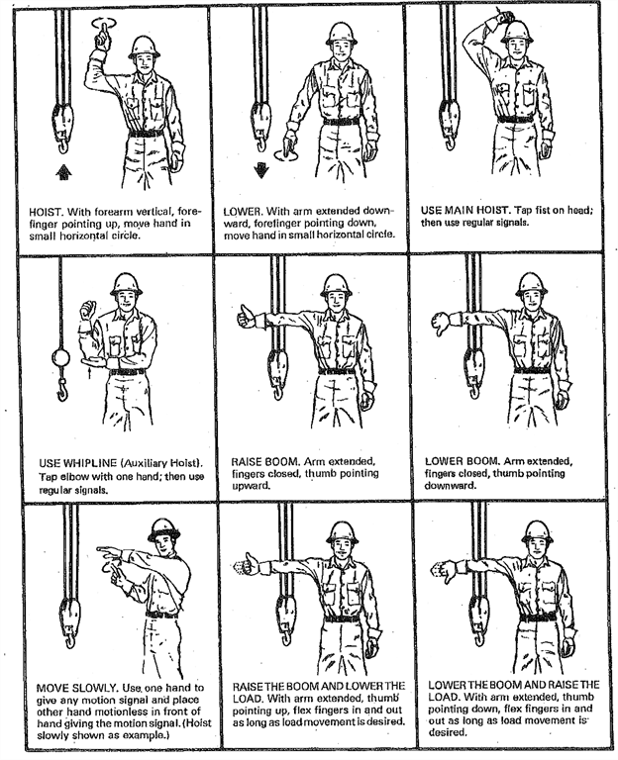
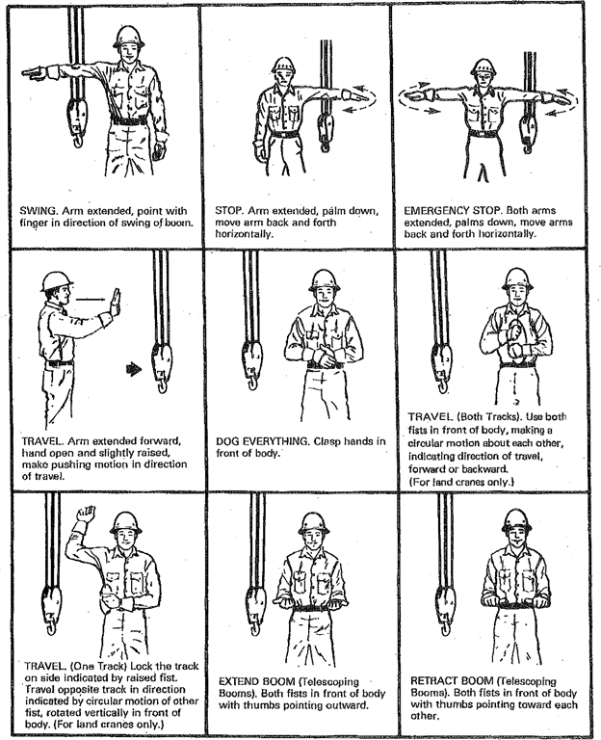

10.0 Training

  - Employees involved in all crane operations shall be trained in:

    - Overhead Power lines

    - Crush/pinch points

    - Certifications for the rigger, signalman and operator are required and will be sufficient to satisfy the training requirements per Federal and State Requirements.

12.0 Attachments
NA

13.0 References

29 CFR 1926.1400 (Nov 2010), Occupational Safety and Health Standards (OSHA) WAC 296-155 Part L, Occupational Health Standards (DOSH)
EM385-1-1, US Army Corps of Engineers Overton Safety Training, Inc.

