APOLLO INDUSTRIAL SAFETY AND HEALTH PROGRAM
Title  ELECTRICAL SAFETY | Number  AISH 29 | Revision  04
 | Effective Date  05/1/2020 | Page  1 of 14

- Purpose

- To define the requirements for electrical safety and provide specific reference sources for other requirements, and to ensure compliance with National Fire Protection Association-National Electrical Code (NFPA-70E), and Federal/State OSHA requirements.

This program has been established to:
- Ensure the safety of employees who may work on or near electrical equipment.
- Ensure that employees understand and comply with safety standards related to electrical work.
- Ensure that employees follow uniform practices while performing electrical work.
- Comply with OSHA Standards according to the following key points:
- Provide and demonstrate a safety program with defined responsibilities.
- Provide personal protective equipment (PPE) for workers.
- Provide documented training to workers.
- Provide appropriate tools for safe work.

- Responsibility

  - The Key Supervisor shall be responsible for the following:

    - Monitoring those operations involving electrical work.

    - Ensure compliance with the provisions of this procedure, including required training and compliance with permits.

    - Ensure that all electrical and arc flash PPE is provided, properly inspected and maintained.

    - Ensure compliance of all applicable Federal / State codes.

    - Complete Electrical Risk Assessment prior to performing electrical work.

  - Industrial Safety and Health (IS&H) shall be responsible for the following:

    - Review and approve required Energized Electrical Work Permits.

    - Provide or assist in the task of specific training for electrical work qualifications.

    - Maintain training recordkeeping.

  - Employees shall be responsible for the following:

    - Immediately report any concerns related to electrical safety to supervision.

    - Properly maintain all personal protective equipment.

    - Wear all required personal protective equipment – there are no exceptions.

    - Inspect electrical safety equipment in accordance with manufacturer’s guidelines and instructions prior to use.

- DEFINITIONS

  - Arc flash: An explosion of radiant and convective energy, arc blast vapors, molten metal droplets, sound pressure, shock waves, intense light and projectiles that occurs in electrical equipment when electricity takes an unattended path (electrical current fault).
  - Arc Flash Hazard: A source of possible injury or damage to health associated with the release of energy caused by and electrical arc.
  - Authorized worker: A person who has completed the required hazardous energy control training and is authorized to lockout or tagout a specific machine or equipment to perform service or maintenance.
  - Boundary, Arc flash: A linear distance in all directions from a prospective arc source within which a person could receive a second degree burn if an electrical arc flash were to occur.
  - Boundary, Limited approach: A linear distance in all directions from an exposed energized electrical conductor or circuit part within which a shock hazard exists. This shock protection boundary is to be crossed by only qualified persons and only to be crossed by unqualified persons only when escorted by a qualified person.
  - Boundary, Restricted approach: An approach limit at a distance from and exposed energized electrical conductor or circuit part within which there is an increased risk of shock, due to electrical arc over combined with inadvertent movement, for personnel working in close proximity to the energized electrical conductor or circuit part.
  - De-energized / Electrically safe working condition: De-energizing and securing energy sources to ensure employee safety. An electrically safe work condition is established by:
- Identifying all sources of the electrical supply.
- Opening the disconnecting device for each supply.
- Visually inspecting where possible, the disconnecting device to ensure that the switch has opened.
- Locking out all disconnecting devices to prevent unexpected re-energization.
- Testing the circuit with an adequately rated test device (voltage tester or volt ohmmeter). The performance of the test instrument must be verified before and after each use.
- Grounding the phase conductors or components if induced voltage or stored electrical energy is present.
  - Electrical Risk Assessment: Assessment used to identify hazards, hazard controls and feasibility of performing live electrical work.
  - Energized: Electrically connected to a source of voltage or otherwise electrically charged with a potential noticeably different than that of the earth.
  - Energized Electrical Work (EEW): Any work on electrical equipment, circuits, devices, systems, or any other energized part(s) where an employee is required to deliberately, or could accidently, place any part of his body, tool, or material into or around such electrical devices where the voltage has been deemed to be 50 volts or more.
  - Ground: A conducting connection, whether intentional or accidental, between an electric circuit or equipment and the earth (or to some conducting body which serves in place of the earth).
  - Ground-Fault Circuit Interrupter (GFCI): A device for the protection of personnel that de-energizes a circuit or portion thereof within an established period of time when current to ground exceeds some predetermined value less than that required to operate the over current protective device of the supply circuit.
  - Qualified Worker: An authorized Service employee who by virtue of experience and training, can safely work on energized electrical systems at greater than 50 volts. This person must have sufficient understanding of electrical devices and facilities to be able to positively identify and control all hazards that may be present.
  - Safety Trained: An authorized worker trained by a competent person to recognize the hazards associated with electrical energy and equipment and has received the Apollo EEW Training.
  - Shock Hazard: A dangerous condition associated with the possible release of energy caused by contact or approach to energized electrical conductors or circuit parts greater than 50 volts.

- GENERAL REQUIREMENTS

Electrical circuits, equipment, and components shall be installed and maintained in accordance with the following requirements:

NOTE: WHEN DEEMED APPROPRIATE, THE IS&H DEPARTMENT MAY, AFTER CAREFUL EVALUATION, GRANT EXEMPTION FROM SPECIAL REQUIREMENTS OF THIS PROCEDURE FOR SPECIFIC ELECTRICAL WORK ON AN INDIVIDUAL BASIS. Justification for granting such exemptions shall be documented on the Energized Electrical Work Permit (attachment AISH 29-A) or on an attachment thereto.

  - Each employee shall receive electrical safety training based on his or her potential exposure. Only qualified persons shall work on or near exposed electrical parts.

  - Conductors and parts of electrical equipment that have been de-energized, but not been locked or tagged out shall be treated as live parts.

  - DE-ENERGIZED / ELECTRICALLY SAFE WORKING CONDITION:

    - Live parts to which an employee may be exposed shall be de-energized and locked and/or tagged (in accordance with AISH 15) before work is performed on or near them. However, in certain situations, de-energizing introduces additional or increased hazards or is infeasible due to equipment design or operational limitations including testing and troubleshooting. An Electrical Risk Assessment shall be performed to help determine the risk and controls. Only in very rare situations is actual work (non-exempted activities) permitted on energized electrical parts. A detailed description of the safety-related work practices to be used to protect employees shall be documented on the Energized Electrical Work Permit when work is deemed not exempt and it is infeasible to remove power. Live parts that operate at less than 50 volts to ground need not be de-energized if there will be no increased exposure to electrical burns or to explosion due to electric arcs.

    - Examples of increased or additional hazards include the following:
- Interruption of life support equipment.
- Deactivation of emergency alarm systems.
- Shutdown of hazardous location ventilation equipment.

    - Examples of work that may be performed on or near energized circuit parts due to equipment design or operational limitations include the following:
      - Testing of electric circuits that can only be performed with the circuit is energized.
      - Work on circuits that form an integral part of a critical continuous process that would otherwise need to be completely shut down in order to permit work on one circuit or piece of equipment.

- Except in special circumstances, normal operations do not constitute a critical continuous process.
Example: While maintaining continuous operation of several computers may be essential to the normal conduct of business, it would not be considered a critical continuous process unless the interruption of electrical power to the computers would result in one of the following:
- A threat to safety or security.
- Loss of critical data.
- Loss of monitoring capability for laboratory/experimental operations.

      - Apollo IS&H shall be consulted when there are questions as to whether an operation is a critical continuous process.

    - Energized Electrical Work Permit: When exposed live parts are not de-energized (for reasons of increased hazards or infeasibility), appropriate safety measures shall be documented on the Energized Electrical Work Permit (Attachment A) and fully implemented to protect employees who may be exposed to the electrical hazards involved.

    - Safety-related work practices shall be designed to protect employees against direct contact of energized circuit parts with any part of the body or indirect contact through some other conductive object.

    - Work practices used shall be suitable for the conditions under which the work is to be performed and for the voltage level of the exposed electric conductors or circuit parts.

  - PERSONAL PROTECTIVE EQUIPMENT:

    - Employees working in areas where there are potential electrical hazards shall be provided with, and shall use, electrical personal protective equipment. The protective equipment shall provide appropriate protection for the specific parts of the body to be protected and for the work to be performed as prescribed in (Attachment B).

    - PPE must be maintained in a safe, reliable condition and be inspected for damage before each day's use and immediately following any incident that can reasonably be suspected of having caused damage.

    - Natural fiber clothing (e.g., cotton, silk, wool, and/or leather) shall be worn by all employees performing work on energized parts. Clothing shall be inspected for rips, tears, and/or flaws in material. If clothing is damaged in any way, it shall not be used.

    - In addition to natural fiber clothing the following types of arc rated PPE that may be used for energized electrical work include, but are not limited to:

- Hardhats
- Hearing Protection
- Safety Glasses
- Rubber insulated mats or boots
- Properly rated and tested insulated gloves
- Properly rated and tested insulated sleeves
- Body hook
- Properly rated and insulated tools
- Insulated blankets
- Non-conductive work platforms
- Face shield
- Properly rated and tested blast suit

    - PPE Testing intervals shall be in accordance with the following table.

Table 130.7(c)(7)(c) Rubber insulating Equipment Maximum Test Intervals
Rubber Insulating Equipment | When to Test | Governing Standard for Test Voltage
Blanket | Before first issue; every 12 months thereafter | ASTM F 479
Covers | If the insulating value is suspect | ASTM F 478
Gloves | Before first issue; every 6 months thereafter | ASTM F 496
Line Hose | If the insulating value is suspect | ASTM 478
Sleeves | Before first issue; every 12 months thereafter | ASTM 496

    - Rubber gloves shall be inspected for holes and air tested before use.

    - Rubber protective equipment shall be inspected, sterilized and tested by an authorized testing organization at six-month intervals.

    - Nonconductive head protection shall be worn whenever there is a danger of head injury from electrical shock or burns due to contact with exposed electrical parts.

    - Face protection shall be worn whenever there shall be danger of injury to the eyes or face from electric arc, flashes, or electrical explosion.

    - Conductive clothing and accessories (e.g., rings, watches, bracelets, metal frame glasses, metal hats, etc.) shall be removed.

    - Only voltage rated insulated tools or insulating protective barriers, which are approved by a nationally recognized testing organization, shall be used.

  - Protective shields, protective barriers or insulating materials as necessary shall be used when working in confined or enclosed work spaces where electrical hazards may exist.

  - Workers shall take special care when handling material in the vicinity of exposed electrical circuits to prevent contact with electrical parts.

  - Signs, barricades, and/or attendants shall be used to isolate the work area and warn others of the exposed energized electrical circuits.

  - Exposed non-current-carrying metal parts of fixed equipment shall be grounded except when specifically excluded by 29 CRF 1910, Subpart S.

  - Exposed non-current-carrying metal parts of cord-and-plug connected equipment shall be grounded.

  - Portable power tools shall be either grounded or of a double insulated type. Double insulated tools shall bear a permanent label identifying them as such.

  - Extension cords shall be grounded, designed for hard or extra-hard usage, and maintained in good repair. Repair to a break in the cord insulation shall be such that the insulating quality of the repair is equal to or greater than the original.

  - Electrical disconnect boxes and distribution panels shall be marked as to distribution/purpose.

  - Unused openings in electrical boxes and fittings shall be effectively closed.

  - Cords shall be protected against damage from traffic, pinch points, and sharp corners. Examples include doorways, roadways, roof edged, etc.

- PROCEDURE

  - DE-ENERGIZED ELECTRICAL WORK

The most important principle of electrical safety is to assume all electric circuits are energized unless each involved worker ensures they are not. Every circuit and conductor must be tested every time work is done on them. Proper PPE must be worn until the equipment is proven to be de-energized.

- Voltage rated gloves and leather protectors must be worn.
- Safety glasses must be worn.
- The required Arc Flash PPE must also be worn when verifying the de-energized state. All arc flash and electrical PPE can be removed once the enclosure has been verified as “dead.”
**See (attachment B) for PPE requirements.

    - Establishing an Electrically Safe Working Condition in accordance with NFPA 70E.

    - Identify all sources of power to the equipment.

    - Remove the load current, and then open the disconnecting devices for each power source.

    - Where possible, visually verify that blades of disconnecting devices are fully open or that draw out type circuit breakers are fully withdrawn.

    - Apply lockout/tagout devices in accordance with a formal, written policy.

    - Test each phase conductor or circuit part with an adequately rated voltage detector to verify that the equipment is de-energized. Test each phase conductor or circuit part both phase-to-phase and phase-to-ground. Check the voltage detector before and after each test to be sure it is working.

    - Properly ground all possible sources of induced voltage and stored electric energy (such as, capacitors) before touching. If conductors or circuit parts that are being de-energized could contact other exposed conductors or circuit parts, apply ground-connecting devices rated for the available fault current.

  - ELECTRICAL RISK ASSESSMENT FORM

Utilizing the Electrical Risk Assessment form, evaluate work activity. This assessment includes a justification for accessing live electrical equipment, an exempted activities list allowing access to live electrical equipment for the sole purpose of the activity listed, an ARC and SHOCK hazard evaluation, and PPE selection. This is the base line form for accessing live electrical equipment, if an activity is not listed as an exempted activity an Energized Electrical Work Permit must be completed to perform the work.

PROVING INFEASABLITY

Measures shall be taken to de-energize all electrical source(s) and ensure that there is no feasible alternative of completing the work in the vicinity of energized parts.

DEFINING LIMITS OF APPROACH and INCIDENT ENERGY

    - Below are the distance boundaries of immediate concern when energized electrical work is performed.
- The shock hazard boundaries are: Restricted and Limited.
- The Arc Flash Hazard boundary is called: Arc-Flash Boundary.

    - A risk assessment shall be performed to determine the voltage to which a worker may become exposed. Electrical approach boundaries can be determined using the NFPA 70E-2018 Tables 130.4 (D) (a) and (b) seen below.

    - Qualified Employees shall adhere to the following tables for approach distances. Approach boundaries to energized electrical conductors or circuit parts for shock protection for alternating current and direct current systems (all dimensions are distance from energized electrical conductor or circuit part to worker)

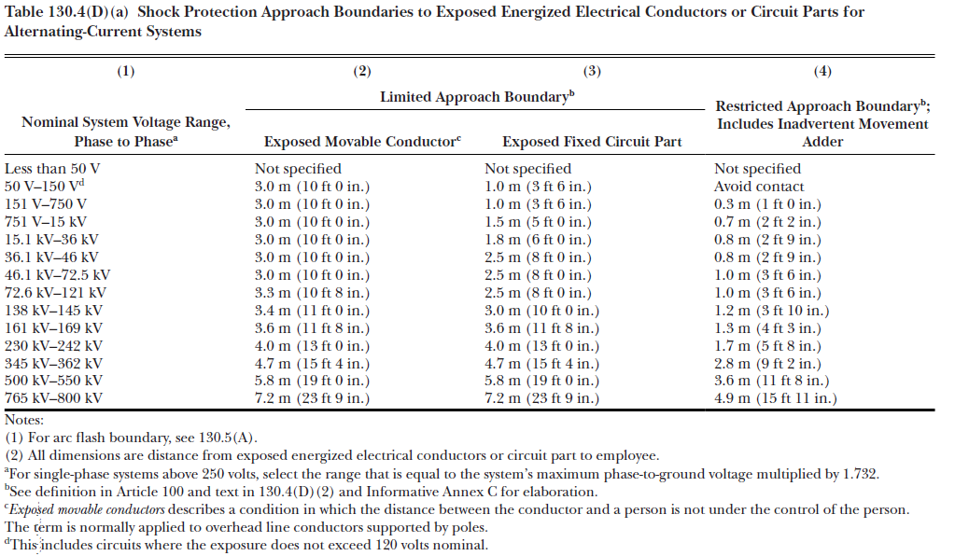

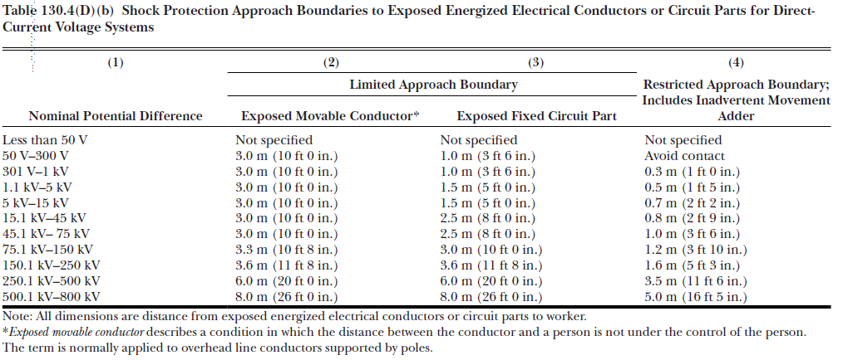
    - An Electrical Risk Assessment shall be performed to determine the arc flash boundary, the incident energy at the working distance, and the appropriate level of PPE to be used. There are two basic means to determine the arc flash boundary and the level of PPE necessary.

      - Incident energy calculation – There are several equations available for calculating the incident energy. These calculations should be carried out by an electrical engineer familiar with the system.

      - Equipment labeling based on a previous incident energy calculation. The label should contain up to date information with back up documentation. The label should also include the following:
- Nominal system voltage.
- Arc flash Boundary.
- At least one of the following:
  - Available incident energy and the corresponding working distance, or the arc flash PPE category.
  - Minimum arc rating of clothing.
  - Site specific level of PPE.

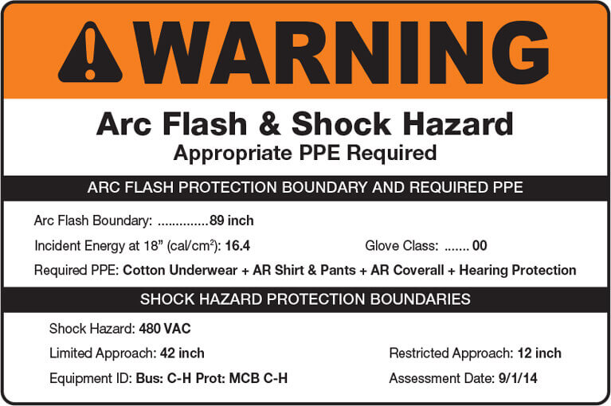

COMPLETING AND ENERGIZED ELECTRICAL WORK PERMIT

    - Key supervisor shall complete Energized Electrical Work Permit and have approved by IS&H. The following conditions shall be followed / considered when completing the permit.
- Workers shall actively participate in establishing protective measures and completing the permit.
- Standardized permits, which are developed and implemented for routine tasks, shall be reviewed periodically (not to exceed 6 months).
- Completed permit shall be available with other pre-job safety planning documents and available at the work location during EEW.
- All covers, doors or similar protective means shall be in place prior to performing EEW.
- Areas around exposed/energized equipment should be properly barricaded and/or secured to prevent accidental contact and maintain a safe work environment.
- Adequate lighting shall be provided in all areas of EEW.
- A detailed PTP shall be completed in addition to EEW Permit.

  - ELECTRICAL TEST EQUIPMENT

    - Only qualified and trained personnel shall use electrical test equipment.

    - Electrical test equipment shall be visually inspected immediately before use and not used if defective. Tagging it out of service identifies defective test equipment.

    - Electrical test equipment shall be only used within manufacturer’s rating and listed applications.

    - When verifying that circuits are de-energized, electrical test equipment shall be checked on a known energized source for proper operation immediately before and after use. Ensure like voltage (AC to AC or DC to DC) is used for testing.

    - When performing zero energy checks, employees shall assure that stored electrical or mechanical energy cannot re-energize the circuit.

  - EQUIPMENT GROUNDING

    - Cord sets, receptacles, and portable and stationary equipment shall be grounded in accordance with the requirements set forth in the standards identified in subsection 4.1.

    - On construction sites, all cord sets, receptacles, and portable equipment connected by a cord or plug shall be visually inspected prior to use.

  - GROUND-FAULT PROTECTION FOR PERSONNEL

    - On construction sites, the Contractor shall provide ground-fault circuit interrupters (GFCI) for all 105-volt, single-phase, 15, 20, and 30-ampere receptacle outlets which are not a part of the permanent wiring of the building or structure. GFCI protection shall cover all cord sets, receptacles which are not part of the permanent wiring of the building or structure, and equipment connected by cord and plug which are available for use by employees.

    - Extension cords, although plugged into a permanent outlet, shall be considered temporary wiring and shall be used only with ground fault circuit interrupters.

EXCEPTION: Receptacles on a 2-wire single phase portable or vehicle-mounted generator rated not more than 5 KW, where the circuit conductors of the generator are insulated from the generator frame and all other ground surfaces.

  - ASSURED GROUNDING PROGRAM

    - Receptacles and cords more than 120-volts shall be part of the assured grounding program or utilize GFCI protection.

    - A competent person shall inspect all cords above 120-volts on a quarterly basis, before first use, before use after any incident that reasonably could cause damage, and after any repair. The inspection shall include the following:

      - Test all equipment grounding conductors for continuity.
      - Test each receptacle or plug to assure the equipment grounding conductor is connected properly.
      - Visually inspect each cord for damage or possible damage.

    - Each cord or receptacle tested on a quarterly basis shall be marked with the corresponding color in accordance with the following table:

Quarter | Months | Color
First | Jan-March | White
Second | April-June | Green
Third | July-Sept | Red
Fourth | Oct-Dec | Orange

  - PORTABLE MULTIPLE OUTLET STRIP

    - Portable multiple outlet strips (also called surge protectors) are permitted for use with computers, video equipment, and other applications where surge protection is desirable. Portable multiple outlet strips shall not be used for refrigerators, microwave ovens, coffee pots, or other applications where permanent wiring is required.

    - Use and care of portable multiple outlet strips shall be in accordance with the requirements of the NEC.

    - Only Underwriters laboratories, Inc. (UL)-listed portable multiple outlet strips shall be used,

    - Portable multiple outlet strips shall be grounded and equipped with internal circuit breaker protection.

    - Portable multiple outlet strips shall not be affixed to structures, furniture, etc.

    - Extension cords shall not be used in conjunction with portable multiple outlet strips.

    - Portable multiple outlet strips shall not be plugged one into another (daisy chained) to accommodate additional appliances/equipment. Where the use of a single portable multiple outlet strip does not provide sufficient quantities of outlets, additional permanent receptacle outlets shall be installed in accordance with applicable codes.

  - OVERHEAD POWER LINES

    - When using equipment or operating motor vehicles around electrical hazards, determine if any part of the operation (crane/derrick, load, load line, excavator, etc.) could get closer than 20 feet of a power line that is up to 345 kV or closer than 50 feet of a power line that exceeds 345kV. If the operation requires the work to be closer than prescribed refer to AISH 37 Overhead Hazards.

6.0 Records

Document | Record Submittal  Responsibility | Record Retention  Responsibility
Energized Electrical Work Permit | Contractor | Construction Management

7.0 References

National Fire Protection Association, National Electric Code (NFPA-70)

8.0 Attachments

AISH 29-A Electrical Risk Assessment
AISH 29-B Energized Electrical Work Permit
AISH 29-C Energized Electrical Work Permit PPE Matrix

Electrical Risk Assessment
- Work Document(s):
- Equipment ID & Locations:
- Justification for Work:
- ☐ Greater Hazard |  |  | - ☐ Infeasibility |  |  |  | - ☐ Less the 50 volts
- Details:
- EEWP Exempted Activity (Select all that Apply):
- ☐ Clearance Activities |  |  | - ☐ Testing & Troubleshooting |  |  |  | - ☐ Visual Inspection
- ☐ Calibration/ adjustment |  |  | - ☐ Voltage & current measurement |  |  |  | - ☐ Work on Class 2 Circuit
- ☐ Safe-to-work check |  |  | - ☐ Remove/ replace cover |  |  |  | - ☐ Escorting unqualified person
- ☐ Installing temporary protective measures (VR shields, guards, insulating equipment) |  |  | - ☐ Resetting overload devices, removing/ installing fuses, etc. when RAB will not be crossed |  |  |  | - ☐ Equipment <50V but increased risk exposure to electrical burns
- Arc Flash Boundary (AFB):
- ☐ <50V  - ☐ Single Phase  - ☐ < 208 V 3 Phase  - ☐ 3 Phase 240V 2000 AMPS (35kV Transformer) |  | - ☐ Arc Flash Label on equipment with AFB, & incident energy or required PPE |  |  | - ☐ Tables 130. (C)(15)(A)(a), 130.7(C)(15)(A)(a), and 130.7(C)(15)(b) |  |  |  | If NO AFB label,  - ☐ Calc #  - AFB:  - Working Distance  - Incident Energy
 |  |  |  |  | PPE Categories
 |  |  |  |  | ☐ 1 (4 cal/cm2)  ☐ 2 (8 cal/cm2) | ☐ 3 (25cal/cm2)  ☐ 4 (40cal/cm2)
- Shock Hazard: |  |  |  |  | - PPE:
- Nominal Voltage |  |  |  |  | - ☐ Hearing Protection  - ☐ Insulated Tools  - ☐ Safety Glasses  - ☐ Hard Hats  - ☐ Face Shield  - ☐ Balaclava  - ☐ Hood |  |  | - ☐ Voltage Rated Gloves  - ☐ w/ Protectors  - ☐ Leather Gloves  - ☐Long Sleeves/pants, or coveralls  - ☐Natural Fibers  - ☐ Arc Rated  - ☐ Arc Suit
- Approach Boundaries | - LAB |  | - RAB
 | ☐ O.L. | ☐Fixed
☐ 50V- 150V | 10’ 0” | 3’ 6” | Avoid Contact
☐ 151V- 750V | 10’ 0” | 3’ 6” | 1’ 0”
☐ 751V- 15KV | 10’ 0” | 5’ | 2’ 2”
Table 130.4(D)
- Energized Electrical Work Permit Required? ☐ YES ☐ NO
Print: |  |  |  | Sign: |  |  |  |  | Date:

APOLLO ENERGIZED ELECTRICAL WORK PERMIT
PROJECT: ___________________________________PROJECT #:________________
LOCATION OF WORK:__________________________________________________
JOB DESCRIPTION
(INCLUDE ACTIVITIES TO BE PERFORMED, COMPONENTS INVOLVED, VOLTAGES, ETC.)
________________________________________________________________________________________________________________________________________________________________________________________________________________________________________________________________________________________________
ENERGIZED ELECTRICAL WORK AUTHORIZATION JUSTIFICATION
( ) INTRODUCES ADDITIONAL HAZARDS ( ) INFEASIBLE DUE TO EQUIPT. DESIGN
( ) INTRODUCES INCREASED HAZARDS ( ) INFEASIBLE DUE TO OPERATIONAL LIMITATIONS
EXPLAIN JUSTIFICATION:______________________________________________
____________________________________________________________________________________________________________________________________________________________________________________________________________________________________
SAFE WORK REQUIREMENTS
( ) Qualified Personnel assigned to perform work.

( ) Person trained in First-Aid/CPR & emergency electrical rescue procedures, standing by.
Standby person to be equipped with insulating equipment needed for rescue.

( ) Adequate working clearance available, escape route(s) in case of emergency.

( ) Communications available and in operating condition. EMERGENCY NUMBER:____________________

( ) Work area has adequate lighting.

( ) Work area control measures: ( ) barriers & signs ( ) attendant

( ) Conductive items removed: metal rings, watches, jewelry, buckles, badge holders, etc.

( ) De-energize and isolate equipment to the extent feasible.

( ) Insulating protective equip. used: ( ) line hoses & covers ( ) rubber insulating matting ( ) rubber blankets

( ) Voltage rated, insulated tools.

( ) Portable ladders with clean & dry, non-conductive side rails.

( ) Testing equipment at work site compatible with voltage present.

( ) Other:_____________________________________________________________________________
LIMITS OF APPROACH
Arc Flash Calculation:______ System voltage:______
Arc Flash Boundary:______ Limited Approach Boundary:______ Restricted Approach Boundary:______

PERSONAL PROTECTIVE EQUIPMENT
Required Per Attachment B (EEW PPE MATRIX)

Hazard/Risk Category 1: 4 cal/cm² ( ) Hazard/Risk Category 3: 8 cal/cm² ( )
Hazard/Risk Category 2: 25 cal/cm² ( ) Hazard/Risk Category 4: 40 cal/cm² ( )

APOLLO SAFETY SIGNOFF:_____________________________________DATE:__________________

SUPERVISOR(S) SIGNOFF:_____________________________________________________________

WORKER(S) SIGNOFF:_________________________________________________________________

AISH 29-C: PPE MATRIX

