- Purpose
  - To define and implement the system for ensuring prompt and correct investigation, notification, and reporting of safety-related events that is in accordance with Apollo Company requirements.

- Responsibility
  - Apollo Key Supervisor shall be responsible for forwarding completed Apollo Accident Report and all other safety-related documents to Apollo Safety.
  - The Key Supervisor shall be responsible for the following event-related activities.
    - Ensuring that all Apollo Employees are trained on this procedure and what is expected of personnel in the event of an event and an investigation or report.

    - Identifying First Aid/CPR/AED qualified personnel on the jobsite or within the crew and informing the employee’s in order to have the knowledge of whom to seek a in the event of an emergency.

    - Ensuring that all events are reported immediately to the Apollo Division Manager and Cooperate Safety and host facility or General Contractor.

    - Ensuring that the event scene is secure from disturbance and unauthorized entry until released by Apollo Safety.

    - Initial identification of evidence immediately following the incident which might include a listing of people, equipment, and materials involved and a recording of environmental factors such as weather, illumination, temperature, noise, ventilation, and physical factors such as fatigue, age, and medical conditions.

    - Assisting Apollo with the collection of all transient evidence for the investigation, and assisting with identification of witnesses.

    - Conducting investigations in accordance with this procedure.

    - Preparing reports in accordance with this procedure.

  - Employees shall be responsible for the following:

    - Preventing a second event, fire, injury, or further damage to the extent possible.

    - Activating emergency assistance systems when required.
    - Immediately reporting all events/accidents to supervision.

    - Securing the scene from disturbance and unauthorized entry.

    - Participating in investigations, as required.

    - Understanding that lying, evidence tampering and knowingly to choose not to report an event could result in termination.

- Definitions

  - Event: An unplanned incident affecting employee health and safety, or causing property/environment damage.

  - Near Miss (Oh Schit…): A narrowly avoided incident that could have affected employee health and safety, or caused property/environmental damage.

- General Requirements
  - All events, regardless of severity, shall be reported to Apollo Key Supervisor.
  - All events, regardless of severity, shall be investigated and documented.
  - Apollo shall ensure that injury/illness recordkeeping and reporting is performed in accordance with OSHA standards.
  - Apollo Safety shall conduct independent investigations on events at the discretion of the Division Manager.
  - In the event of an investigation the following shall be available:
    - Any and all equipment necessary to carry out a full and accurate investigation.
    - Participation from all involved employees such as witness statements, isolation of evidence, area protected from tampering of others and all other appropriate actions of involvement for a full an accurate investigation.
  - Apollo Safety shall review all documents and reports to ensure completeness and meaningful responses.
  - Make sure employee take “Apollo Return to Work (Attachment 8-D)” form with them to doctor’s clinic.
- Procedure
  - Reporting of Accidents/Injuries
Employees receiving personal injury are encouraged to report to the nearest medical care/emergency assistance. All injuries must be reported, to Apollo Supervision and Safety Department.
Employees are responsible for notifying their supervisor if they are fatigued to the point of not being able to perform their duties safely.
    - Accident Reporting
      - An Apollo Accident Report shall be completed for any of the following events: (Apollo Accident Report 8-A)
        - First Aid Injury
        - Personal injury accidents as follows:
          - OSHA Recordable Case
          - Receive medical attention off site
        - Environmental incidents – releases and spills.
        - Accidents resulting in property damage.
        - Vehicle accidents resulting in damages exceeding $500.
        - Near-miss incidents.
        - Or as determined by Safety or Management.
      - The Accident Report/Investigation shall be completed in detail by the Key Supervisor and/or Apollo Safety describing the following items:
        - Activity in progress at time of accident/incident/
        - Events, beginning with initiation of the activity and ending with nature and extent of the injury/damage.
        - Accident causes (direct cause, contributory cause, and root cause) including conditions and/or actions and mitigating factors influencing them.
        - Corrective action planned and taken to prevent the accident/incident from reoccurring.
      - Within 24 hours of the event, the Accident Report is submitted to Apollo Safety.
      - Witness Statements shall be obtained from all personnel at the site. (8-C)
      - Required incidents must be verbally reported to applicable regulatory agency(s) within 8 hours of their discovery. Incidents must also be reported to the client as soon as possible or in a timely manner (within 24 hours of incident).
  - Follow-up for Events/Accidents: The following actions shall be implemented:
    - Prevent immediate second event, fire, or emergency in the facility and/or area.
    - Implement rescue procedures and/or appropriate medical care for injured personnel.
    - Notify Apollo Division Manager and Safety Department.
    - Secure the event scene from disturbance and unauthorized entry pending arrival of Apollo Safety.
    - Keep equipment or articles involved in the event from being operated, moved, or otherwise altered or repaired.
    - If determined necessary, obtain photographs of the event scene and any equipment involved, e.g., motor vehicles, excavating equipment, ladders, scaffolds, etc.
    - Assist Apollo and/or identify witnesses; secure statements from those who were directly involved or who may have witnessed the event.
    - With Apollo, develop plans for the reactivation of the facility, area process, or operations.
    - If an Apollo investigation is conducted, assign a trained individual to serve as liaison to arrange for needed assistance and gathering evidence.
    - Complete required reports.
    - Participate in Root cause Determinations, facilitated by Apollo Management.
  - Tracking and Trending
    - A lessons-learned shall be generated from all injuries/accidents that are determined recordable or property damage resulting in $1000 of damage. The lessons-learned shall be forwarded to all Key Supervisors for discussion in the following safety meetings.
    - An “OH Schit” report shall be generated for any near misses that have valuable lessons that others within Apollo can learn from. The “Oh Schit” report shall be forwarded to all key supervisors for discussion in the following safety meetings.
    - All accident report will be inputted into the Safety departments trending and tracking system to help identify trends.
    - The trends report will be covered at Safety Leadership Meeting.
  - Injured Employee
    - Apollo Safety will help facilitate and manage the injured employee return to work process and claims management.
    - Ensure injured employee receives prompt medical treatment.
    - Light duty employee’s will not work any overtime.
    - Apollo is committed to do whatever is necessary to return all injured employees to job of injury.
    - Apollo will offer employee light duty/transitional jobs during the injured employee recover process. Apollo will also offer permanent job transfer if it will benefit the employee and Apollo.
    - If the employee is unable to return to work in light duty, Apollo with keep the employee on Kept on Salary (KOS).
      - Light Duty Process/KOS
        - The project is responsible for all cost associated with Light Duty/KOS. If light duty is not available on the project of injury the Safety Department will help facilitate light duty options. Regardless of where the employee is working light duty, the job of injury will cover all costs.
        - If the job ends the Project Manager shall move the employee to their new job and transfer cost to that job.

- Records

  - The following records are submitted to Apollo and maintained by the in accordance with this procedure:
    - Accident Report
    - OSHA 300 logs (submit only when requested)
    - Lessons Learned

- References
N/A
- Attachments
AISH 8-A Apollo Accident and Incident Report
AISH 8-B Lessons Learned
AISH 8-C OH Schit…
AISH 8-D Apollo Witness Statement
AISH 8-E Return to Work Slip

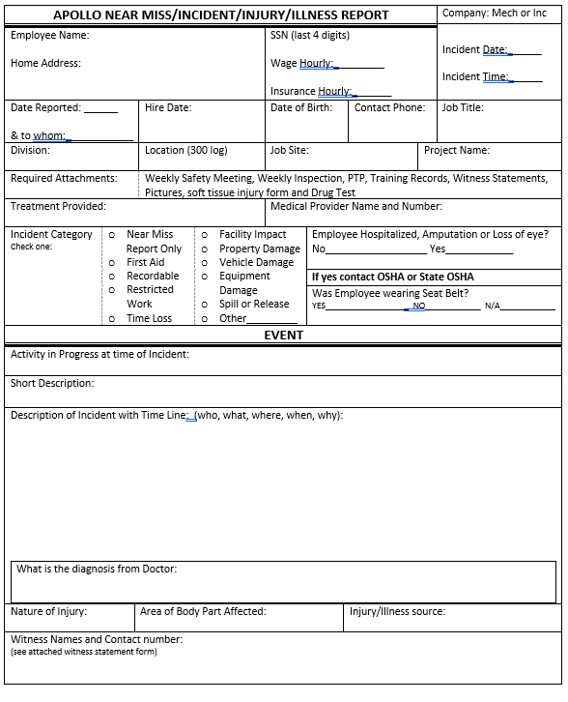
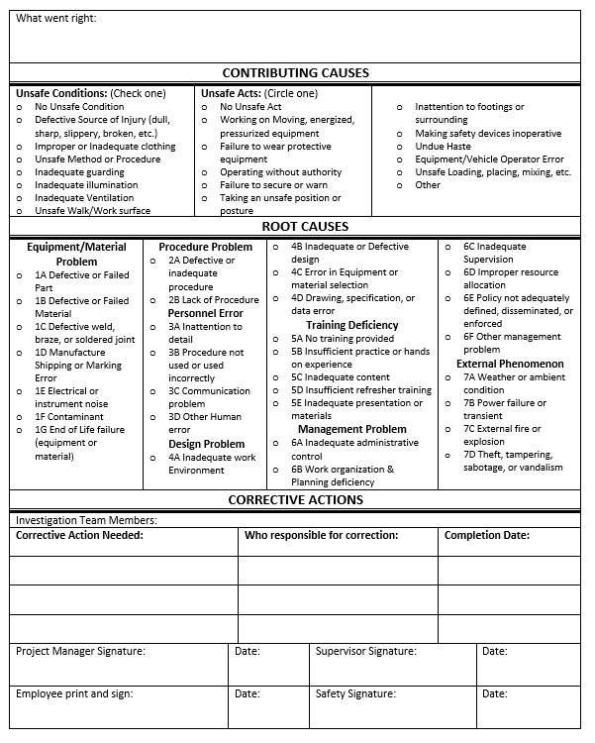

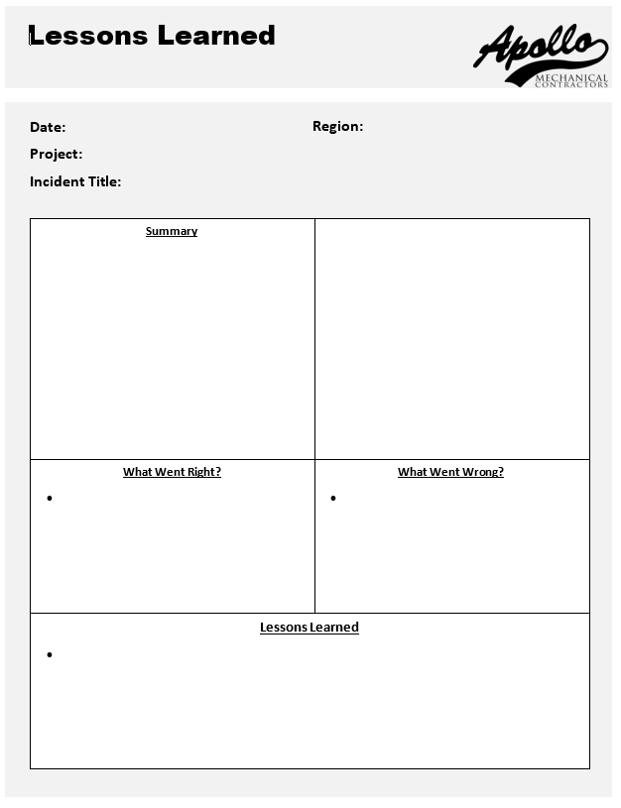

OH Schit…

Date:

;
LKADF
Division/Project:
Title:
What the *#$!?

Did we get that on film?

Lady Luck highlights of what went right

The Oops!

Would’ve, Could’ve, Should’ve

