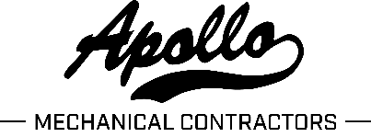

OH Schit…

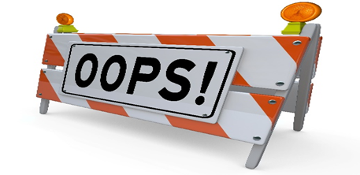

**Date:**

**;**

**;**

**LKADF**

**Division/Project:**

**Title:**

**What the *#$!?**

**Did we get that on film?**

**Lady Luck highlights of what went right**

**The Oops!**

**Would of, Could of, Should of**